|  | **INSTITUTE OF TECHNOLOGY AND MANAGEMENT SKILLS UNIVERSITY,**  **KHARGHAR, NAVI MUMBAI** |
| --- | --- |

**C++ PROGRAMMING LAB**



**Prepared by:**

Name of Student: Riya Singh

Roll No:26

Batch: 2023-27

**DEPARTMENT OF COMPUTER SCIENCE & ENGINEERING**

| **Exp. No** | **List of Experiment** |
| --- | --- |
| 1 | Write a program to find the roots of a quadratic equation. |
| 2 | Write a program to calculate the power of a number using a loop. |
| 3 | Write a program to check if a given string, is a palindrome. |
| 4 | Write a program that simulates a simple ATM machine, allowing users to check their balance, deposit, or withdraw money using a switch statement. |
| 5 | Write a program that finds the largest among three numbers using nested if-else statements |
| 6 | Write a program that determines the grade of a student based on their marks of 5 subjects using if-else-if ladder. |
| 7 | Write a program to find the sum of digits of a number until it becomes a single-digit number. |
| 8 | Write a program to print a Pascal's triangle using nested loops. |
| 9 | Write a program to calculate the sum of series 1/1! + 2/2! + 3/3! + ... + N/N! using nested loops. |
| 10 | Write a program to create an array of strings and display them in alphabetical order. |
| 11 | Write a program that checks if an array is sorted in ascending order. |
| 12 | Write a program to calculate the sum of elements in each row of a matrix. |
| 13 | Write a program to generate all possible permutations of a string. |
| 14 | Create a C++ program to print the following pattern:  *****  * *  * *  * *  ***** |
| 15 | Write a C++ program to display the following pattern:  1  232  34543  4567654  34543  232 |
| 16 | Write a program to creating an inventory management system for a small store. The system should use object-oriented principles in C++. Your program should have the following features:   * + Create a **Product** class that represents a product in the inventory. Each **Product** object should have the following attributes:     - Product ID (an integer)     - Product Name (a string)     - Price (a floating-point number)     - Quantity in stock (an integer)   + Implement a parameterized constructor for the **Product** class to initialize the attributes when a new product is added to the inventory. |
| 17 | Write a program to manage student records. Create a class Student with attributes such as name, roll number, and marks. Implement methods for displaying student details, adding new students, and calculating the average marks of all students in the record system. |
| 18 | Write a program that implements a basic calculator. Use a class Calculator with methods to perform addition, subtraction, multiplication, and division of two numbers. The program should allow the user to input two numbers and select an operation to perform. |
| 19 | Write a program to simulate a simple online shop. Create a class Product with attributes like name, price, and quantity in stock. Implement methods for adding products to the shopping cart, calculating the total cost, and displaying the contents of the cart. |
| 20 | Write a program to manage student grades for a classroom. Create a class Student with attributes for student name and an array to store grades. Implement methods for adding grades, calculating the average grade, and displaying the student's name and grades. Use constructors and destructors to initialize and release resources. |
|  |  |
|  |  |

**Name of Student:Riya Singh**

**Roll Number: 26**

**Experiment No:1**

**Title:Write a program to find the roots of a quadratic equation.**

**Theory: • Quadratic equations are of the form ax^2 + bx + c = 0, with roots given by (-b ± √(b^2 - 4ac)) / (2a). • The discriminant (b^2 - 4ac) determines the nature of roots: positive for real roots, zero for repeated roots, and negative for imaginary roots**

**Code://Write a program to find the roots of a quadratic equation**

**#include <iostream>**

**#include <cmath>**

**using namespace std;**

**int main() {**

**double a, b, c;**

**//Input coefficients from the user**

**cout << "Enter coefficient a: ";**

**cin >> a;**

**cout << "Enter coefficient b: ";**

**cin >> b;**

**cout << "Enter coefficient c: ";**

**cin >> c;**

**// Calculate the discriminant (b^2 - 4ac)**

**double discriminant = b * b - 4 * a * c;**

**// Check the discriminant to determine the nature of roots**

**if (discriminant > 0) {**

**// Two distinct real roots**

**double root1 = (-b + sqrt(discriminant)) / (2 * a);**

**double root2 = (-b - sqrt(discriminant)) / (2 * a);**

**cout << "Roots are real and distinct:" << endl;**

**cout << "Root 1 = " << root1 << endl;**

**cout << "Root 2 = " << root2 << endl;**

**} else if (discriminant == 0) {**

**// One real root (double root)**

**double root = -b / (2 * a);**

**cout << "Roots are real and identical:" <<endl;**

**cout << "Root = " << root << endl;**

**} else {**

**// Complex roots**

**double realPart = -b / (2 * a);**

**double imaginaryPart = sqrt(-discriminant) / (2 * a);**

**cout << "Roots are complex and conjugate:" << endl;**

**cout << "Root 1 = " << realPart << " + " << imaginaryPart << "i" << endl;**

**cout << "Root 2 = " << realPart << " - " << imaginaryPart << "i" << endl;**

**}**

**return 0;**

**}**

**Output: (screenshot)**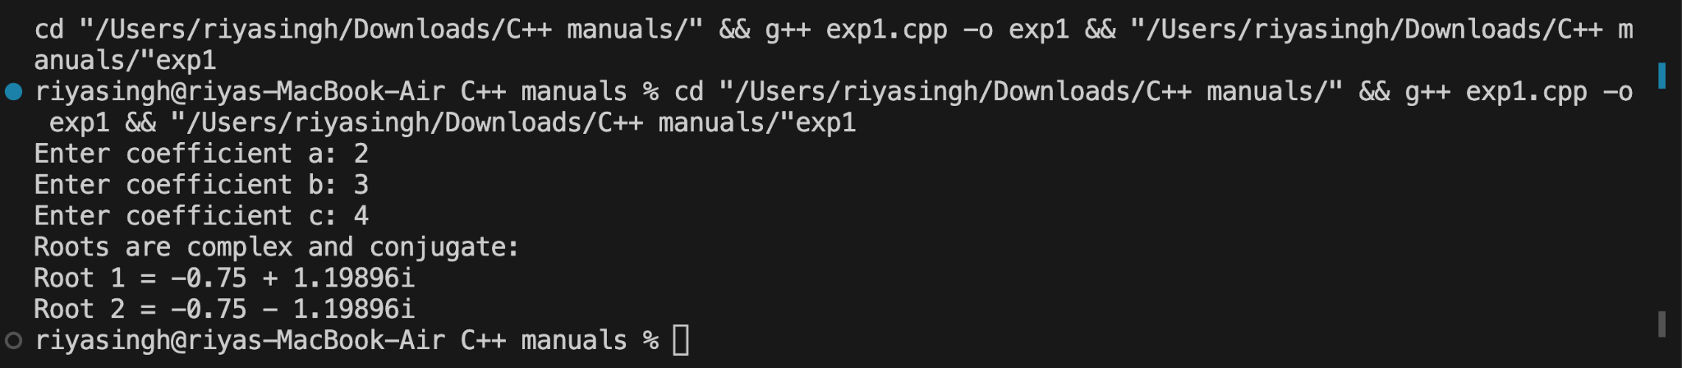

**Test Case: Any two (screenshot)1.**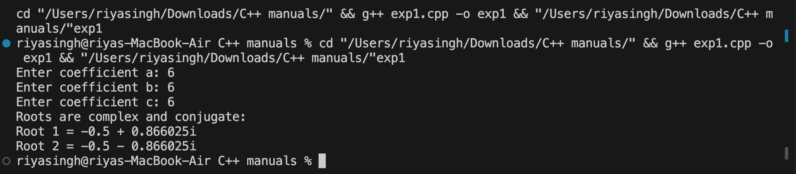

**2.**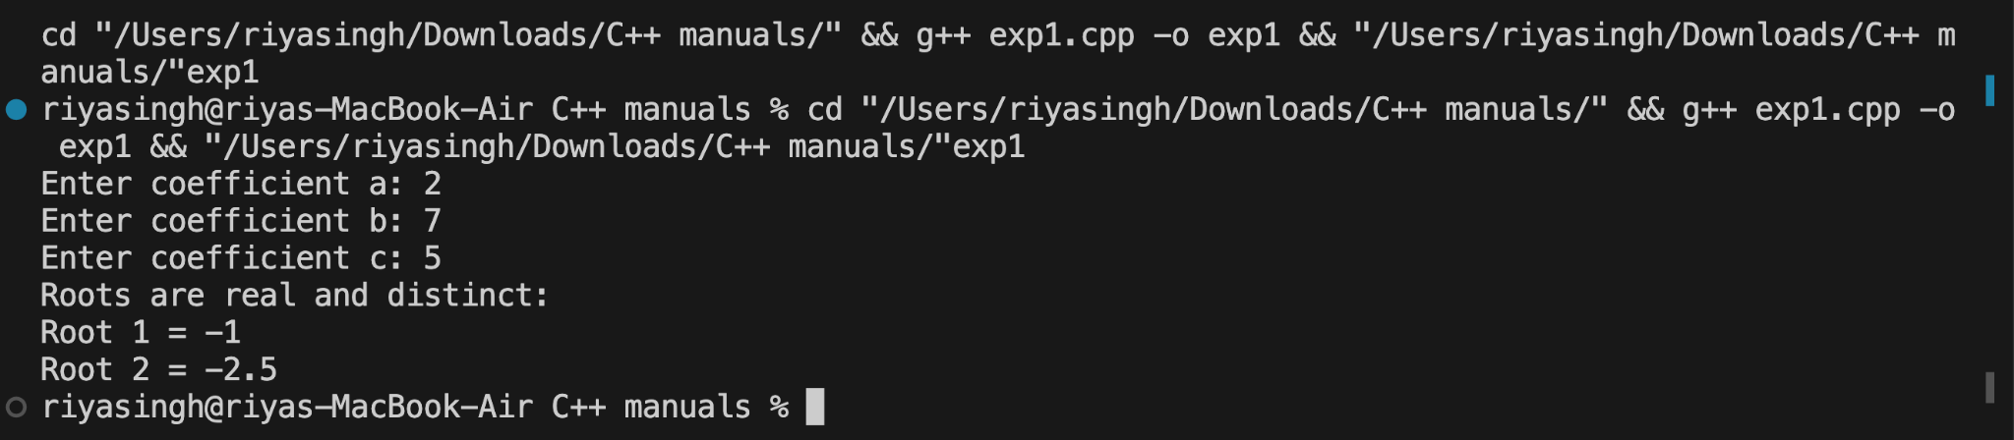

**Conclusion:The program is working accurately and The program accurately calculates the roots of a quadratic equation, providing real, repeated, or imaginary solutions based on the discriminant**

**Experiment No:02**

**● TITLE-**Write a program to calculate the power of a number using a loop.

**● THEORY- ●** Power calculation involves multiplying the base by itself for the specified exponent using a loop. ● The loop iterates through the exponent, updating the result by multiplying it with the base in each iteration

**CODE-//Write a program to calculate the power of a number using a loop.**

**#include <iostream>**

**using namespace std;**

**int main() {**

**int base, power, result = 1;**

**cout << "Enter the base: ";**

**cin >> base;**

**cout << "Enter the power: ";**

**cin >> power;**

**// Calculate power using a loop**

**for (int i = 0; i < power; ++i) {**

**result *= base;**

**}**

**cout << "Result: " << result << endl;**

**return 0;**

**}**

**Output:**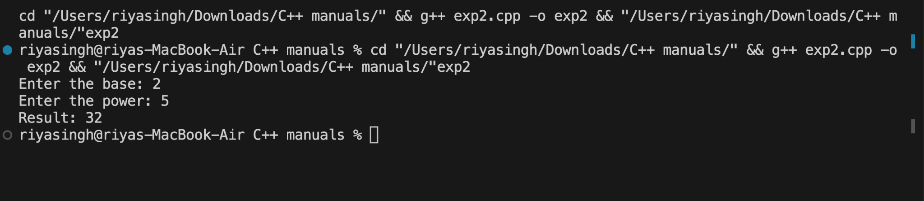

**Test Result(Any 2 Screenshot):1.**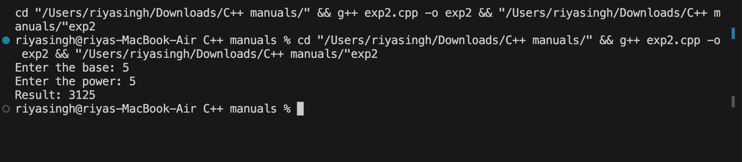

**2.**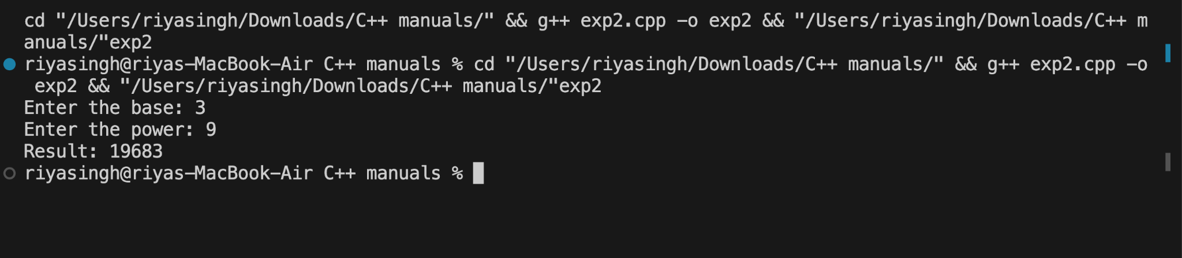

**CONCLUSION:**The program effectively computes the power of a number using a loop, providing the result by iteratively multiplying the base with itself according to the given exponent.

**Experiment No:03**

● **TITLE**-Write a program to check if a given string, is a palindrome.

● **THEORY** - ● • A palindrome is a string that reads the same backward as forward. ● •The program compares characters from both ends, moving towards the center, to determine if the given string is a palindrome.

**Code ://Write a program to check if a given string, is a palindrome**

**#include <iostream>**

**using namespace std;**

**int main()**

**{**

**string n;**

**int len, a = 0;**

**cout << "Enter the string : \n";**

**cin >> n;**

**len = n.length();**

**for (int i = 0; i < len / 2; i++)**

**{**

**if (n[i] == n[len - i - 1])**

**{**

**a++;**

**}**

**}**

**if (a == len / 2)**

**{**

**cout << "\n"**

**<< n << " is palindrome";**

**}**

**else**

**{**

**cout << "\n"**

**<< n << " is not palindrome";**

**}**

**return 0;**

**}**

**Output(Screenshot):**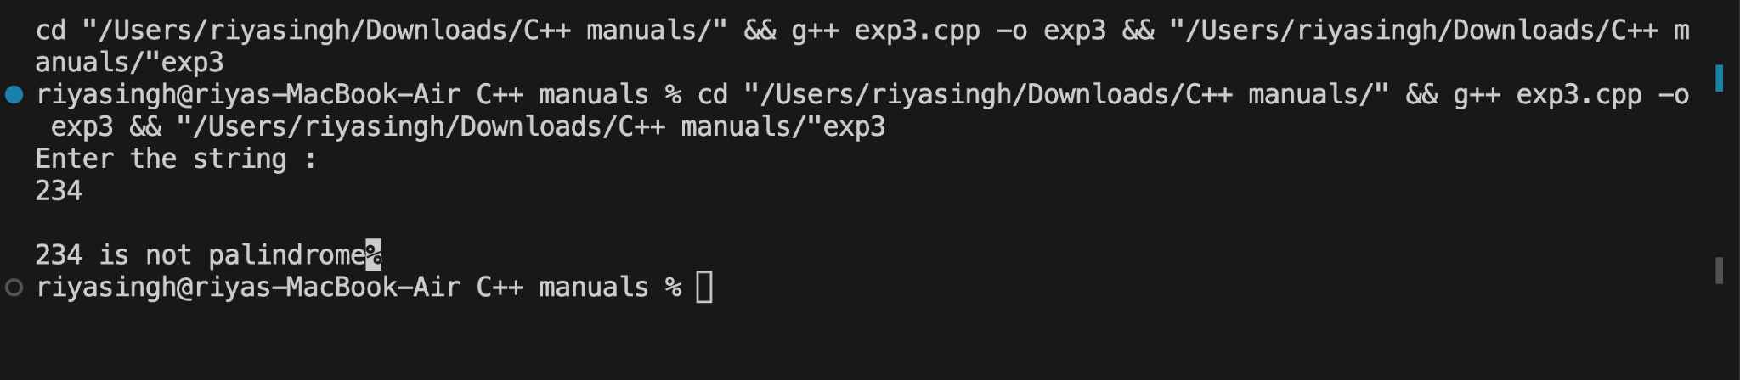

**Test Result(Any2 Screenshot):1.**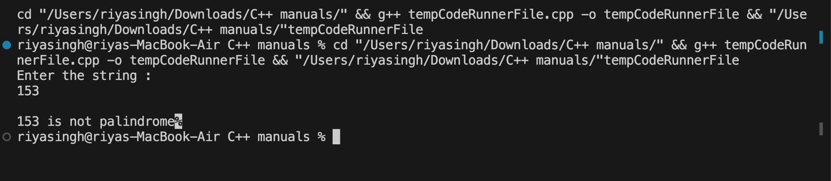

**2.**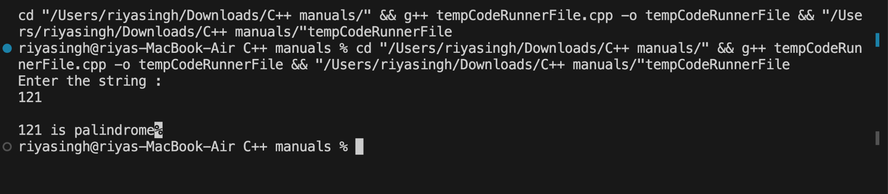

**CONCLUSION:**

The program is properly checking weather the string is palindrome or not . By comparing characters from start to end .

**Experiment No:04**

● **TITLE**- Write a program that simulates a simple ATM machine, allowing users to check their balance, deposit, or withdraw money using a switch statement.

● **THEORY**- ● The program uses a switch statement to offer options like checking balance, depositing, and withdrawing money in a simple ATM simulation. ● Each case in the switch statement executes the corresponding operation based on user input

● **CODE-#include <iostream>**

**using namespace std;**

**int main()**

**{**

**float balance = 10000.00;**

**int choice;**

**float amount;**

**while (true)**

**{**

**cout << "Welcome to the ATM Machine" << endl;**

**cout << "1. Check Balance" << endl;**

**cout << "2. Deposit Money" << endl;**

**cout << "3. Withdraw Money" << endl;**

**cout << "4. Exit" << endl;**

**cout << "Enter your choice: ";**

**cin >> choice;**

**switch (choice)**

**{**

**case 1:**

**cout << "Your balance is: $" << balance << endl;**

**break;**

**case 2:**

**cout << "Enter the amount you want to deposit: $";**

**cin >> amount;**

**balance += amount;**

**cout << "Deposit successful. Your new balance is: $" << balance << endl;**

**break;**

**case 3:**

**cout << "Enter the amount you want to withdraw: $";**

**cin >> amount;**

**if (amount > balance)**

**{**

**cout << "Insufficient funds!" << endl;**

**}**

**else**

**{**

**balance -= amount;**

**cout << "Withdrawal successful. Your new balance is: $" << balance << endl;**

**}**

**break;**

**case 4:**

**cout << "Thank you for using the ATM!." << endl;**

**return 0;**

**default:**

**cout << "Invalid choice. Please try again." << endl;**

**break;**

**}**

**}**

**return 0;**

**}**

**Output(Screenshot):**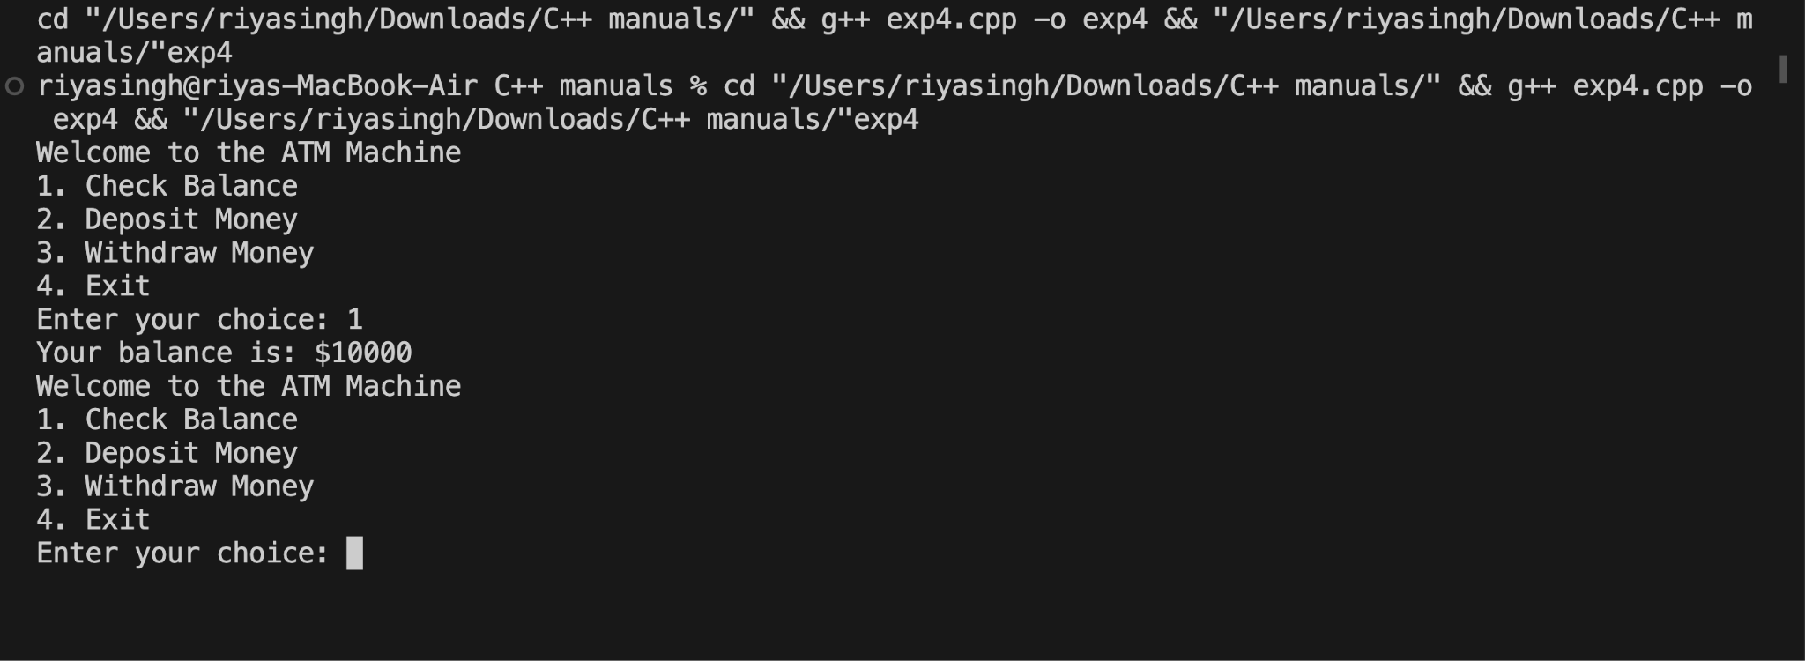

**Test Result(Any2 Screenshots):1.**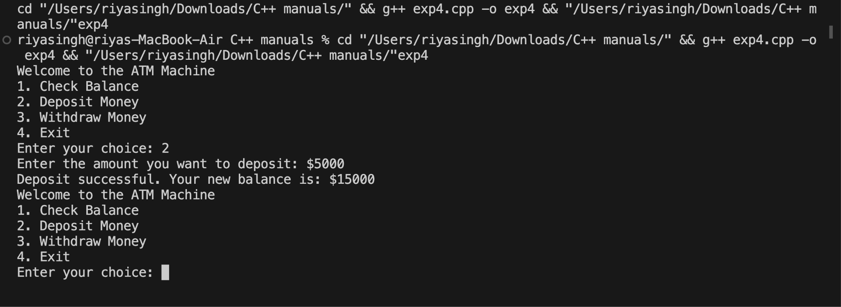

**2.**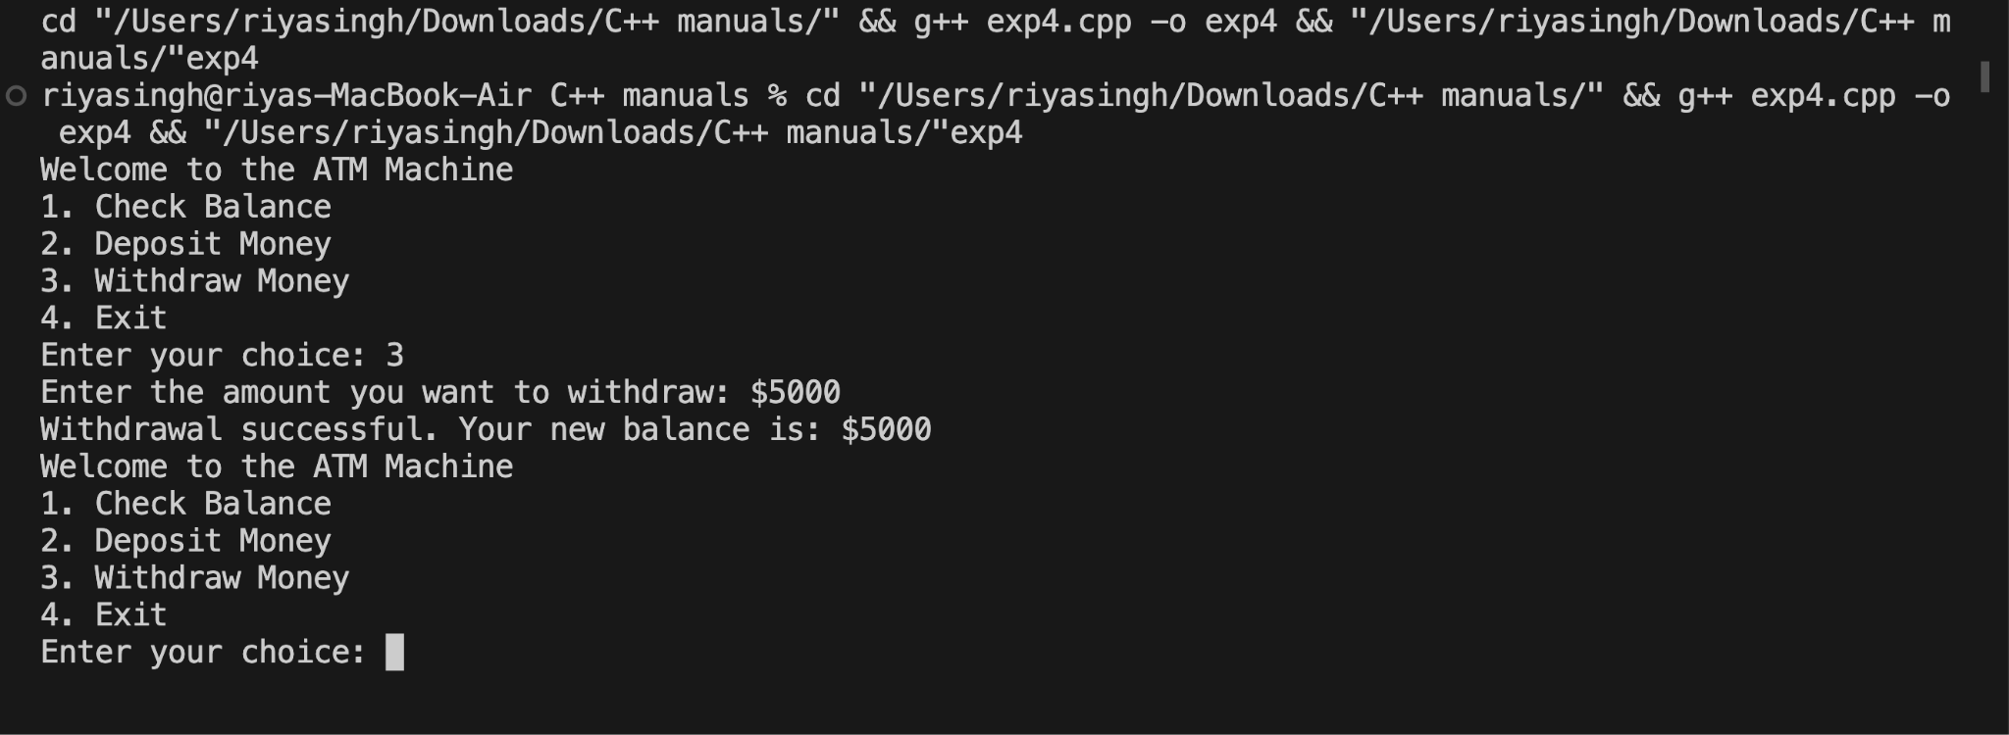

**● CONCLUSION-** The program successfully simulates an ATM, enabling users to check balance, deposit, or withdraw money through a user-friendly switch statement interface.

**Experiment No:05**

● **TITLE**-Write a program that finds the largest among three numbers using nested if-else statements

● **THEORY**-The program is using nested if-else statements to determine the largest number among three ● If three numbers are equal is says all three numbers are equal .

**Code :**

**#include <iostream>**

**using namespace std;**

**int main(){**

**int a,b,c;**

**cout<<"Enter a number-";**

**cin>>a;**

**cout<<"Enter a number2-";**

**cin>>b;**

**cout<<"Enter a number3-";**

**cin>>c;**

**if (a>b && a>c){**

**cout<<"a is greater";**

**}**

**else if (b>a && b>c)**

**{**

**cout<<"b is greater";**

**}**

**else if (c>a && c>b)**

**{**

**cout<<"c is greaters ";**

**}**

**else**

**cout<<"all are equal";**

**return 0;**

**}**

**Output(Screenshot):**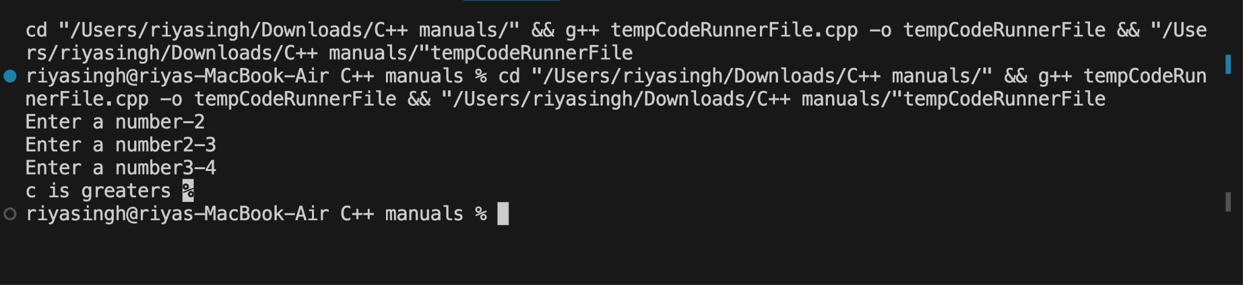

**Test Result(Any 2 Screenshot):1.**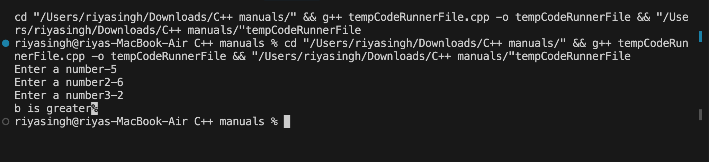

**2.**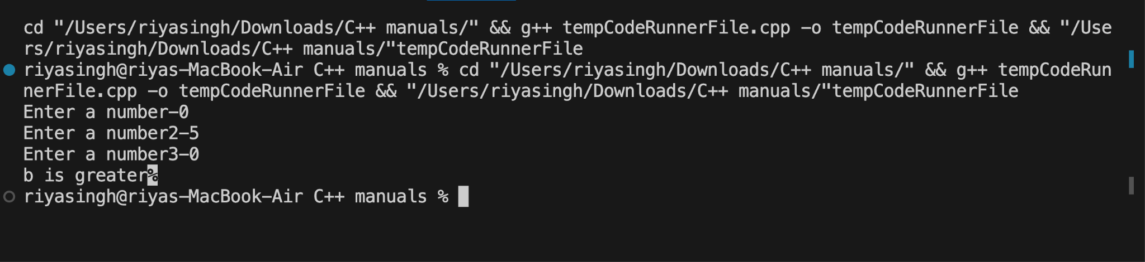

**● CONCLUSION-**  The program is giving accurate result states the biggest number among three and if numbers given are equal it says all numbers are equal

**Experiment No:06**

● **TITLE**-Write a program that determines the grade of a student based on their marks of 5 subjects using if-else-if ladder.

● **THEORY**- The program employs an if-else-if ladder to evaluate a student's grade based on marks in 5 subjects. It checks different conditions for various grade ranges, assigning the corresponding grade based on the total marks.

**Code :**

**#include <iostream>**

**using namespace std;**

**int main()**

**{**

**// Get marks for 5 subjects**

**double subject1, subject2, subject3, subject4, subject5;**

**cout << "Enter marks for Subject 1: ";**

**cin >> subject1;**

**cout << "Enter marks for Subject 2: ";**

**cin >> subject2;**

**cout << "Enter marks for Subject 3: ";**

**cin >> subject3;**

**cout << "Enter marks for Subject 4: ";**

**cin >> subject4;**

**cout << "Enter marks for Subject 5: ";**

**cin >> subject5;**

**// Calculate average marks**

**double average = (subject1 + subject2 + subject3 + subject4 + subject5) / 5;**

**// Determine the grade based on average marks**

**char grade;**

**if (average >= 90)**

**{**

**grade = 'A';**

**}**

**else if (average >= 80)**

**{**

**grade = 'B';**

**}**

**else if (average >= 70)**

**{**

**grade = 'C';**

**}**

**else if (average >= 60)**

**{**

**grade = 'D';**

**}**

**else**

**{**

**grade = 'F';**

**}**

**// Display the result**

**cout << "Average Marks: " << average << endl;**

**cout << "Grade: " << grade << endl;**

**return 0;**

**}**

**Output(Screenshot):**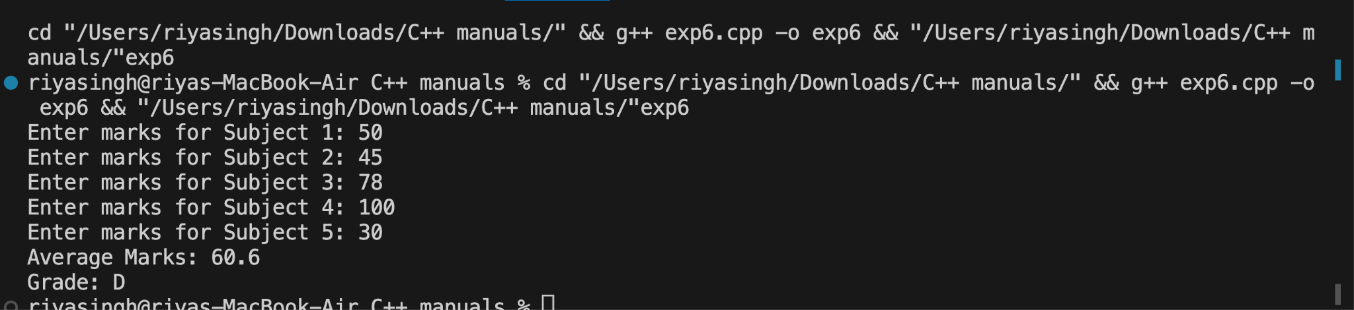

**Test Result(Any 2 Screenshot):1.**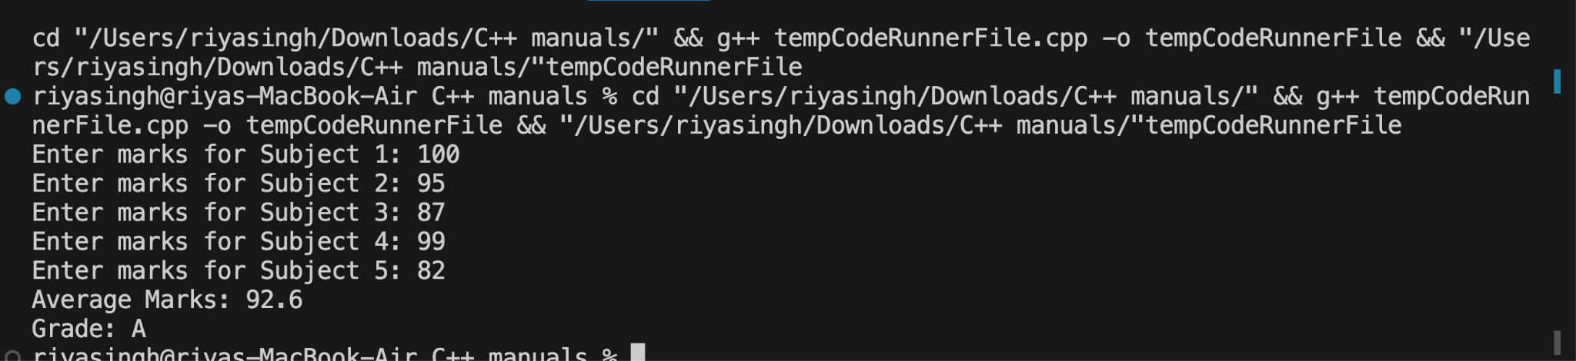

**2.**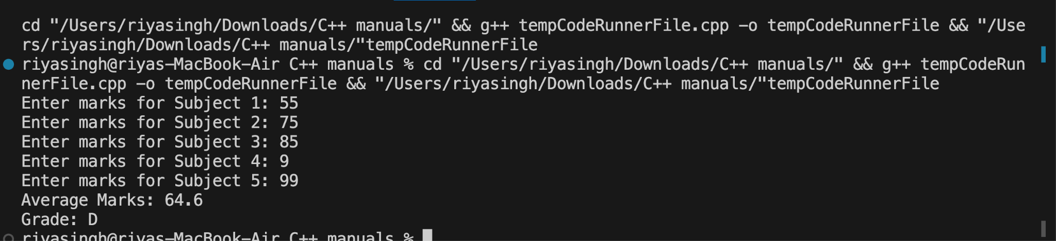

**● CONCLUSION -** The program accurately assigns a grade to a student by evaluating the total marks in 5 subjects using an if-else-if ladder.

**Experiment No:07**

● **TITLE**-Write a program to find the sum of digits of a number until it becomes a single-digit number.

● **THEORY-** The program uses a loop to repeatedly sum the digits of a number until it becomes a single-digit number. It extracts and adds each digit in the loop until the sum is

**Code :**

**#include <iostream>**

**using namespace std;**

**int main()**

**{**

**int n, digit, sum;**

**cout << "Enter number : ";**

**cin >> n;**

**recheck:**

**sum = 0;**

**while (n > 0)**

**{**

**digit = n % 10;**

**sum += digit;**

**n /= 10;**

**}**

**if (sum > 10)**

**{**

**n = sum;**

**goto recheck;**

**}**

**cout << sum;**

**return 0;**

**}**

**Output(Screenshot):**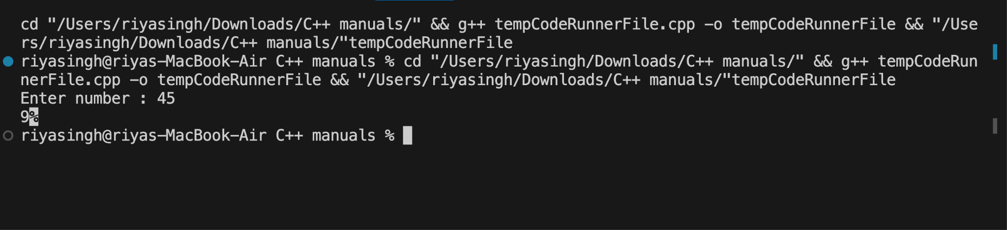

**Test Result(Any 2 Screenshot):1.**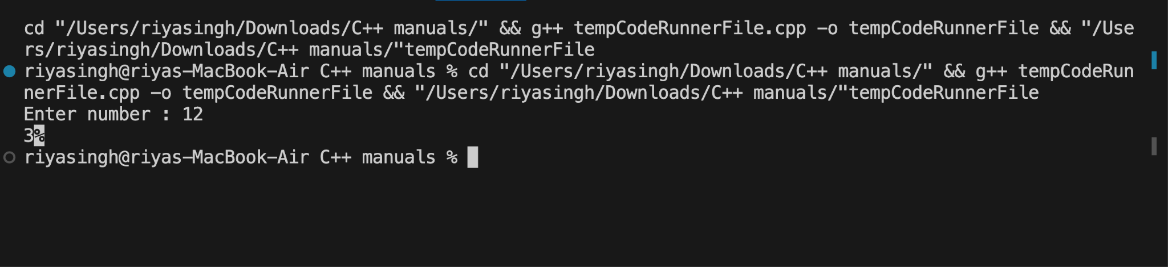

**2.**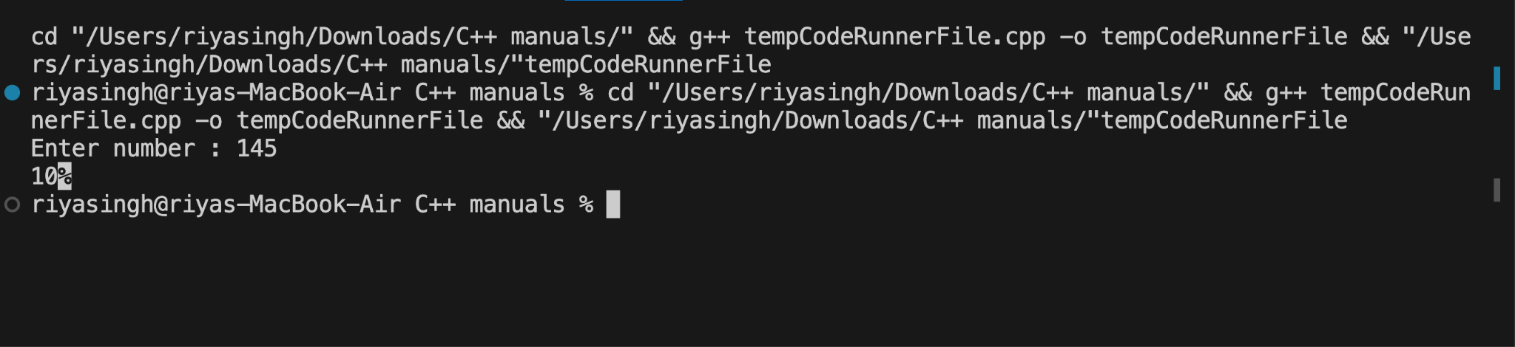

**● CONCLUSION-** The program sucessfully calculates sum of number until it becomes a singl digit number.

**Experiment No:08**

● **TITLE-** Write a program to print a Pascal's triangle using nested loops.

● **THEORY-** Pascal's triangle is formed by summing adjacent elements from the row above. The program uses nested loops to calculate and print the coefficients, arranging them in a triangular pattern.

**Code :**

**#include <iostream>**

**using namespace std;**

**int main()**

**{**

**int n;**

**cout << "Enter number: ";**

**cin >> n;**

**while (n <= 0)**

**{**

**cout << "Invalid number" << endl;**

**cout << "Enter number: " << endl;**

**cin >> n;**

**}**

**cout << "The pattern is: " << endl**

**<< endl;**

**for (int i = 1; i <= n; i++)**

**{**

**int num = 1;**

**for (int j = 1; j <= n - i; j++)**

**{**

**cout << " ";**

**}**

**for (int k = 1; k <= i; k++)**

**{**

**cout << num << " ";**

**num = num * (i - k) / k;**

**}**

**cout << endl;**

**}**

**return 0;**

**}**

**Output(Screenshot):**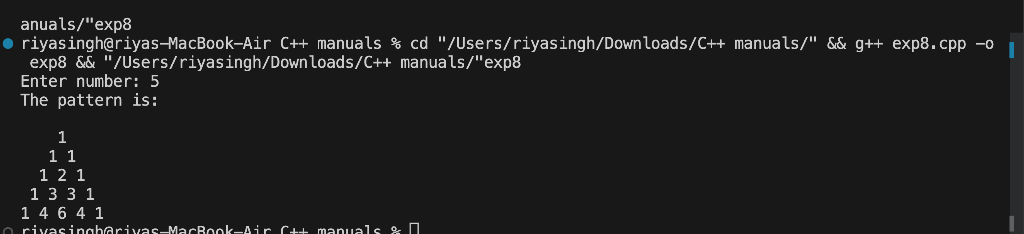

**Test Result(Any 2 Screenshot):1.**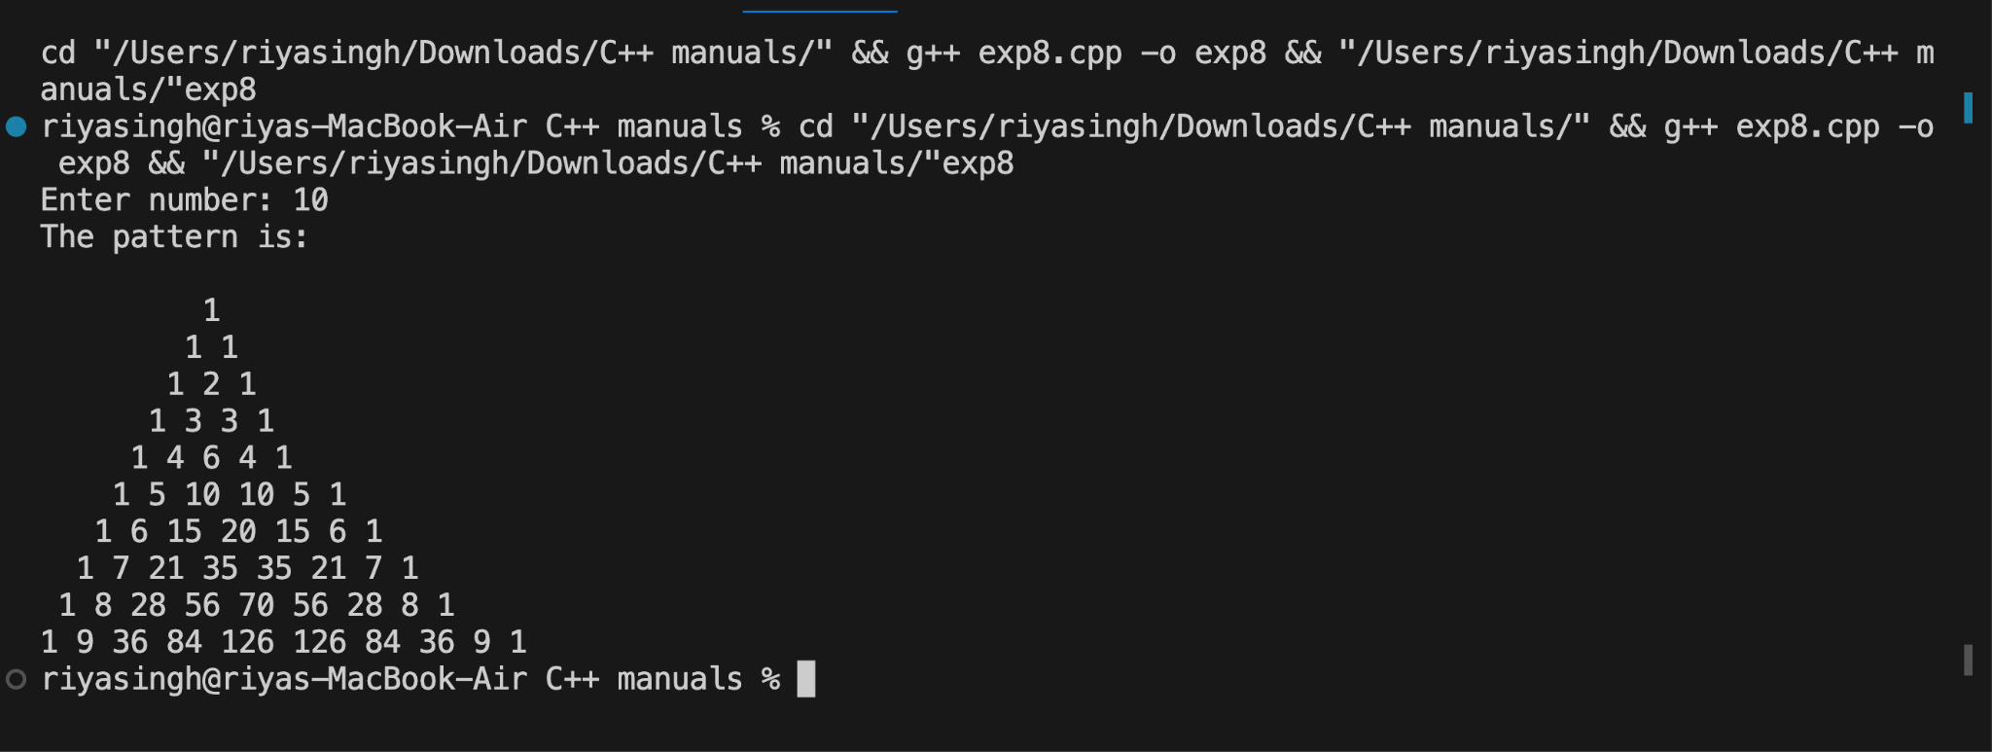

**2.**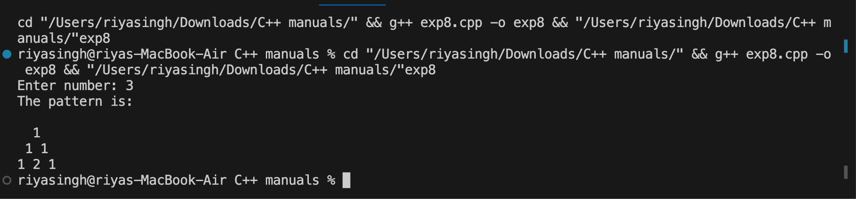

**● CONCLUSION-** The program effectively prints Pascal's triangle using nested loops, showcasing the pattern of coefficients formed by adding adjacent elements from the row above.

**Experiment No:09**

● **TITLE-** Write a program to calculate the sum of series 1/1! + 2/2! + 3/3! + ... + N/N! using nested loops.

● **THEORY**- The program uses nested loops to calculate the sum of the series 1/1! + 2/2! + 3/3! + ... + N/N!. Nested loops compute each term of the series, where the inner loop calculates the factorial.

**Code:**

**#include <iostream>**

**using namespace std;**

**int main(){**

**int n , p = 0 , q = 1 ;**

**float sum = 0;**

**cout<<"Number you want series till : \n";**

**cin>>n;**

**while(n>0)**

**{**

**for(int i = 1 ; i <= n ; i++)**

**{**

**p = i;**

**q =+ q*i;**

**if(i == n)**

**{**

**cout<<p<<"/"<<q<<" = "<<sum+(float(p)/float(q))<<"\n\n";**

**return 0;**

**}**

**else**

**{**

**cout<<p<<"/"<<q<<" + ";**

**sum += float(p)/float(q);**

**}**

**}**

**}**

**cout<<"Invalid input please put positive number greater than zero ..Thank you\n\n";**

**return 0;**

**}**

**Output(Screenshot):**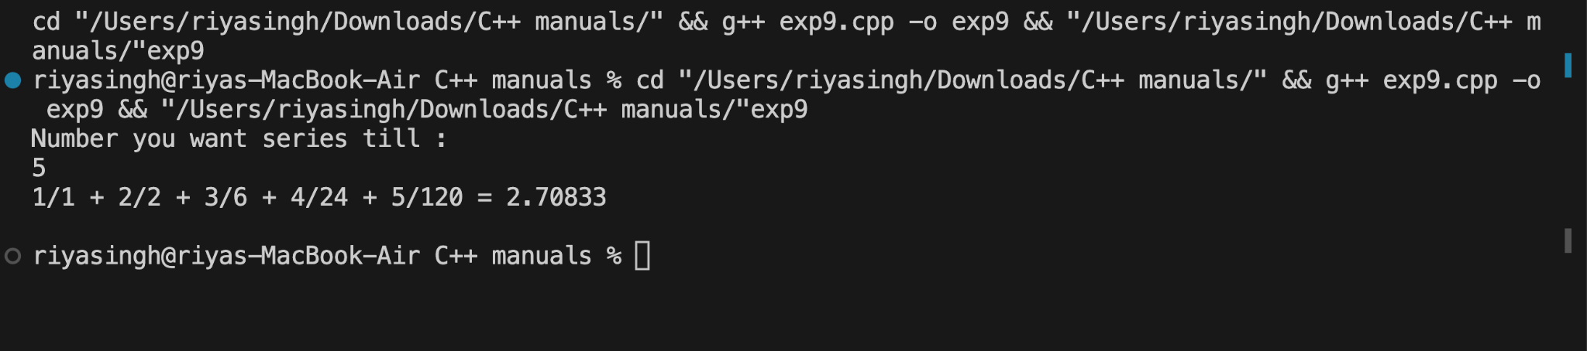

**Test Result(Any 2 Screenshot):1.**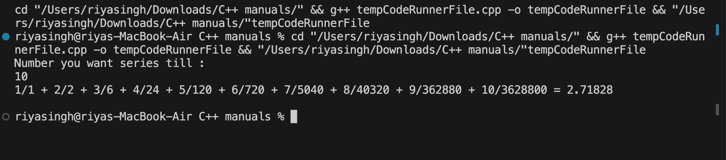

**2.**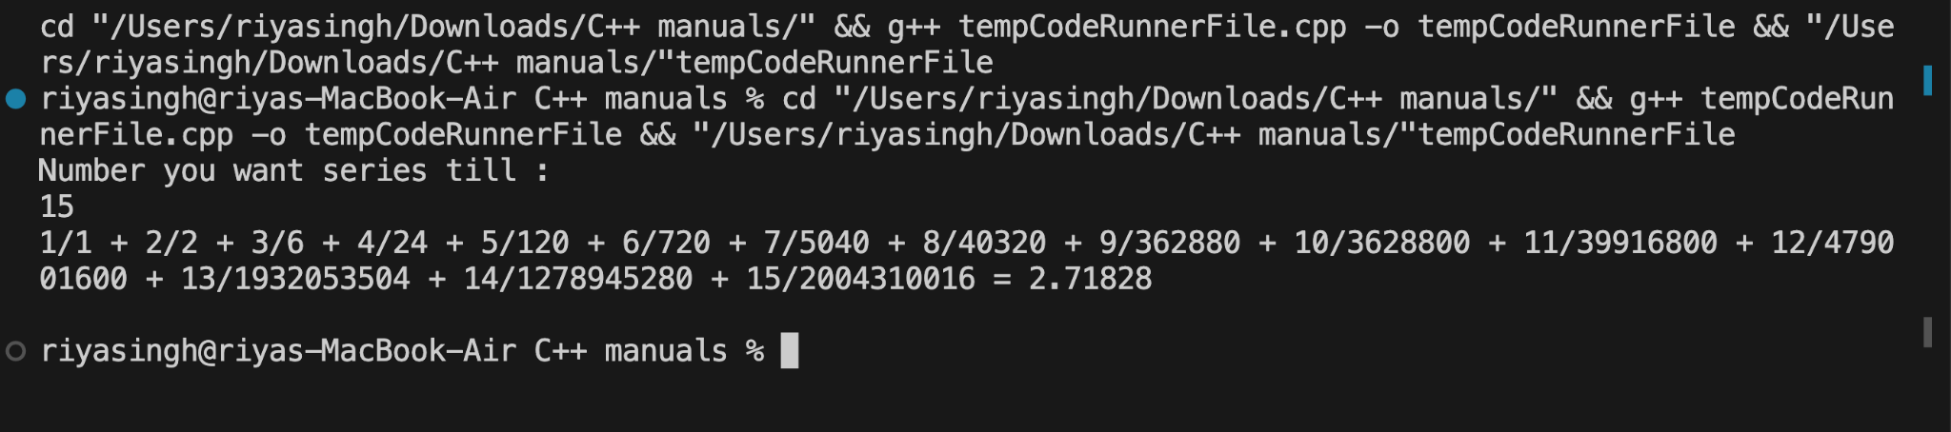

**● CONCLUSION- T**he program accurately calculates and displays the sum of the series 1/1! + 2/2! + 3/3! + ... + N/N! using nested loops

**Experiment No:10**

● **TITLE**-Write a program to create an array of strings and display them in alphabetical order.

● **THEORY**- The program creates an array of strings and sorts them alphabetically using a sorting algorithm. It arranges the strings in ascending order and displays the sorted array

**Code :**

**#include <iostream>**

**using namespace std;**

**string toupper(string a)**

**{**

**string n;**

**for (int i = 0; i < a.length(); i++)**

**{**

**char c = a[i];**

**n += toupper(c);**

**}**

**return n;**

**}**

**int main()**

**{**

**int n;**

**string temp;**

**cout << "No. of string you want to enter : ";**

**cin >> n;**

**string arr[n];**

**for (int i = 0; i < n; i++)**

**{**

**switch (i)**

**{**

**case 0:**

**cout << "Enter 1st Word : ";**

**cin >> arr[i];**

**continue;**

**case 1:**

**cout << "Enter 2nd Word : ";**

**cin >> arr[i];**

**continue;**

**case 2:**

**cout << "Enter 3rd Word : ";**

**cin >> arr[i];**

**continue;**

**default:**

**break;**

**}**

**cout << "Enter " << i + 1 << "th word : ";**

**cin >> arr[i];**

**}**

**for (int i = 0; i < n; i++)**

**{**

**for (int j = 0; j < n; j++)**

**{**

**if (toupper(arr[i]) > toupper(arr[j]))**

**{**

**temp = arr[j];**

**arr[j] = arr[i];**

**arr[i] = temp;**

**}**

**}**

**}**

**cout << "[";**

**for (int i = n - 1; i >= 0; i--)**

**{**

**cout << arr[i] << " | ";**

**}**

**cout << "]";**

**return 0;**

**}**

**Output(Screenshot):**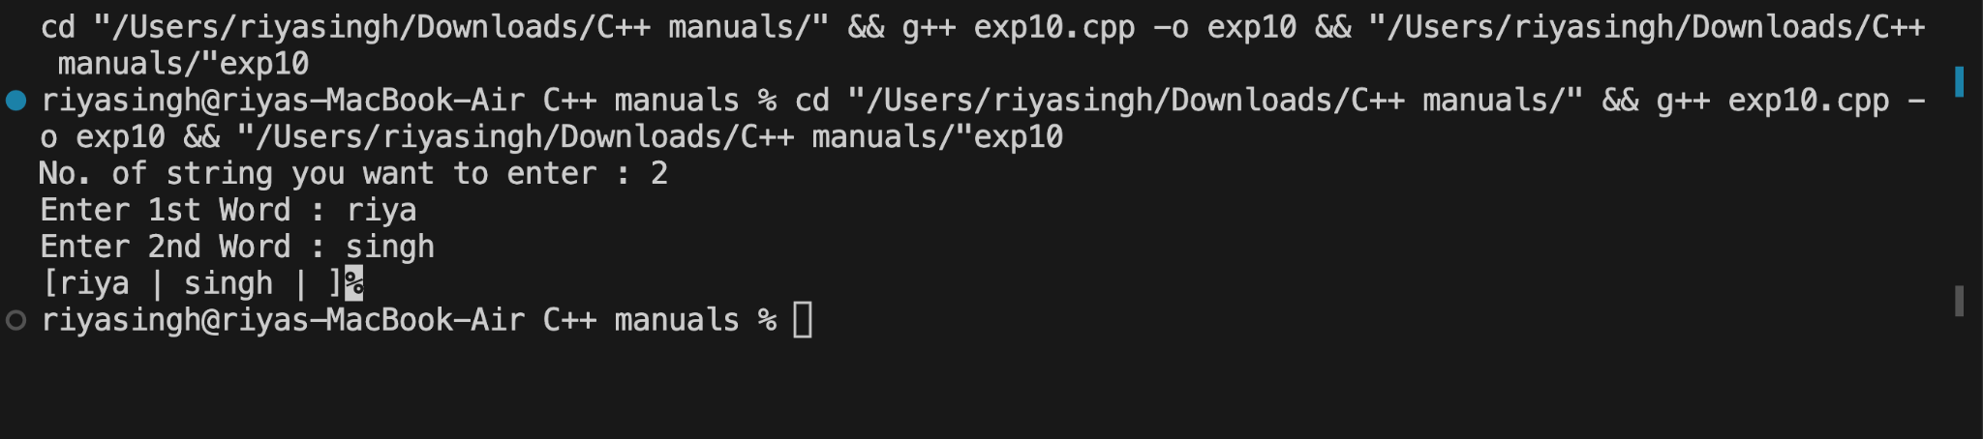

**Test Result(Any 2 Screenshot):1.**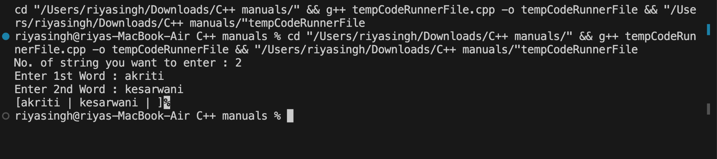

**2.**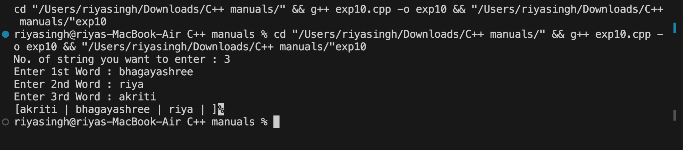

**● CONCLUSION-** The program successfully creates an array of strings and displays them in alphabetical order through a sorting algorithm, ensuring a clear and organized output.

**Experiment No:11**

● **TITLE**-Write a program that checks if an array is sorted in ascending order.

● **THE0RY**- The program checks if an array is sorted in ascending order by comparing each element with the next one. It iterates through the array, verifying that each element is less than or equal to the next

**Code:**

**#include <iostream>**

**using namespace std;**

**int main()**

**{**

**float temp;**

**int n;**

**bool check;**

**cout << "Enter the number of numbers you want to enter : ";**

**cin >> n;**

**float arr[n];**

**for (int i = 0; i < n; i++)**

**{**

**cout << "Enter " << i + 1 << " element";**

**cin >> arr[i];**

**}**

**for (int i = 0; i < n - 1; i++)**

**{**

**if (arr[i] > arr[i + 1])**

**{**

**check = false;**

**}**

**}**

**if (check == false)**

**{**

**cout << "The array is not in ascending order.\nSorted array : ";**

**}**

**else**

**{**

**cout << "Array is in ascending order ";**

**return 0;**

**}**

**for (int i = 0; i < n; i++)**

**{**

**for (int j = 0; j < n; j++)**

**{**

**if (arr[i] < arr[j])**

**{**

**temp = arr[i];**

**arr[i] = arr[j];**

**arr[j] = temp;**

**}**

**}**

**}**

**for (int i = 0; i < n; i++)**

**{**

**cout << arr[i] << " ";**

**}**

**return 0;**

**}**

**Output(Screenshot):**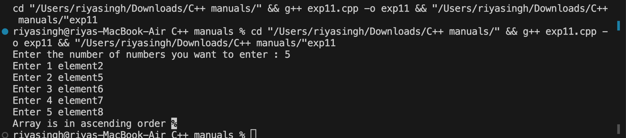

**Test Result(Any 2 Screenshot):1.**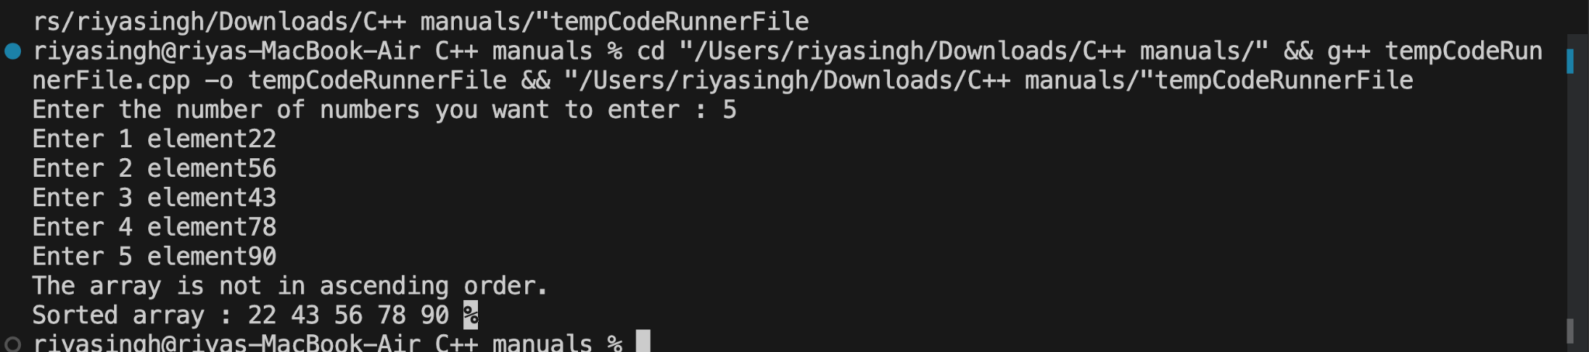

**2.**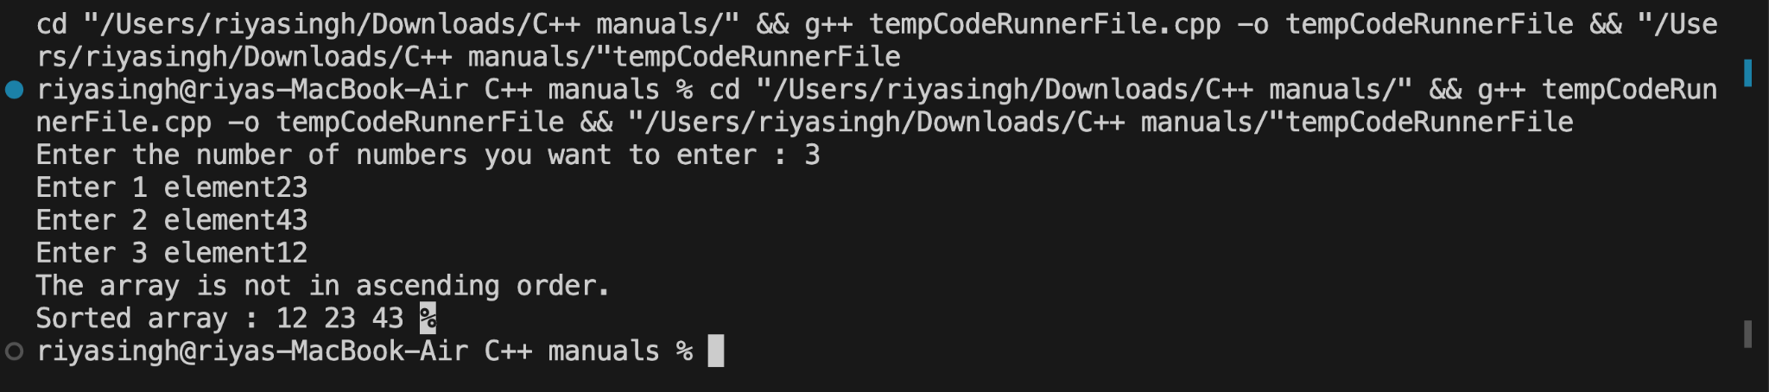

**● CONCLUSION:** The program accurately determines whether the given array is sorted in ascending order by comparing each element with the succeeding one.

**Experiment No:12**

**TITLE**-Write a program to calculate the sum of elements in each row of a matrix.

**THEORY :**The program calculates the sum of elements in each row of a matrix using nested loops. It iterates through each row, adding up the elements, and displays the sum for each row.

**Code :**

**#include <iostream>**

**using namespace std;**

**int main()**

**{**

**int rows, cols;**

**cout << "Enter the number of rows: ";**

**cin >> rows;**

**cout << "Enter the number of columns: ";**

**cin >> cols;**

**int matrix[rows][cols];**

**cout << "Enter the matrix elements:" << endl;**

**for (int i = 0; i < rows; ++i)**

**{**

**for (int j = 0; j < cols; ++j)**

**{**

**cout << "Enter element at position (" << i + 1 << "," << j + 1 << "): ";**

**cin >> matrix[i][j];**

**}**

**}**

**cout << "Sum of elements in each row:" << endl;**

**for (int i = 0; i < rows; ++i)**

**{**

**int rowSum = 0;**

**for (int j = 0; j < cols; ++j)**

**{**

**rowSum += matrix[i][j];**

**}**

**cout << "Row " << i + 1 << ": " << rowSum << endl;**

**}**

**return 0;**

**}**

**Output(Screenshot):**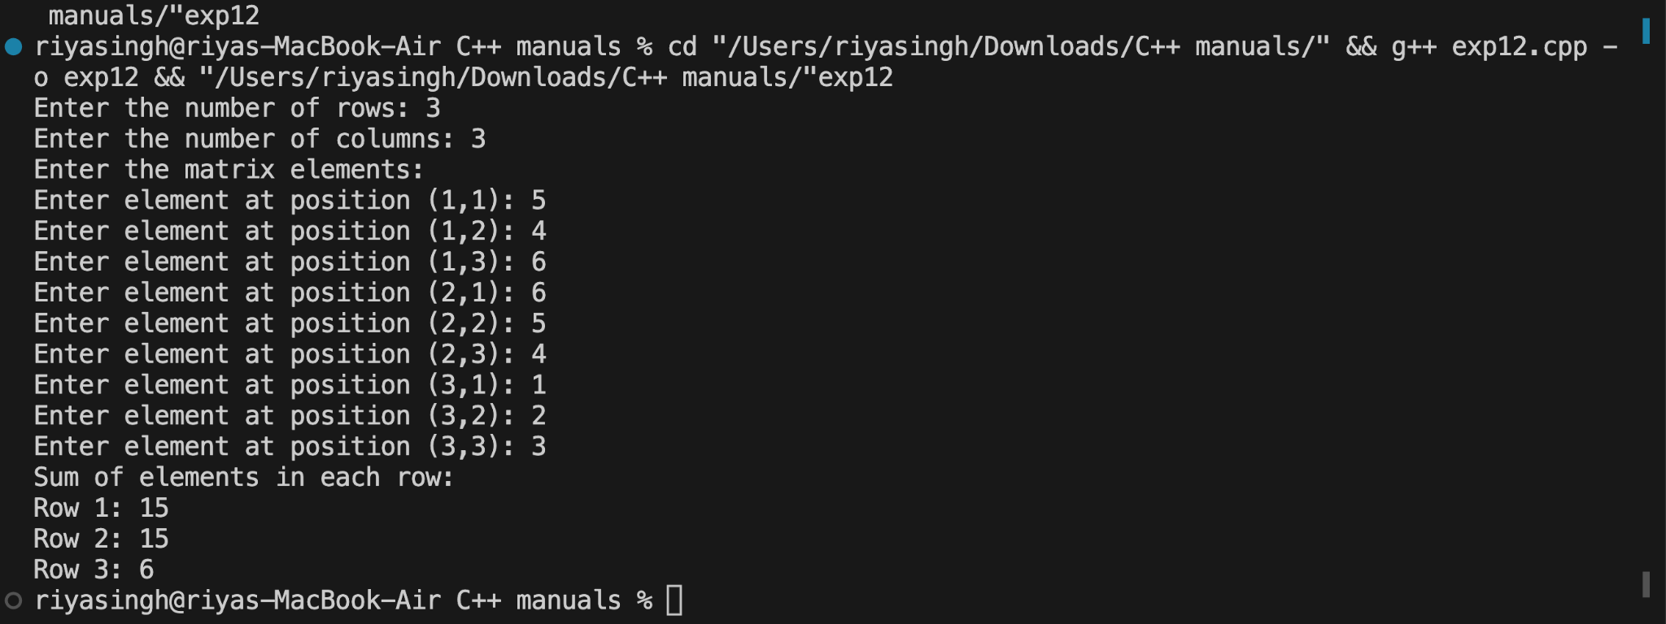

**Test Result (Any 2 Screenshot):1.**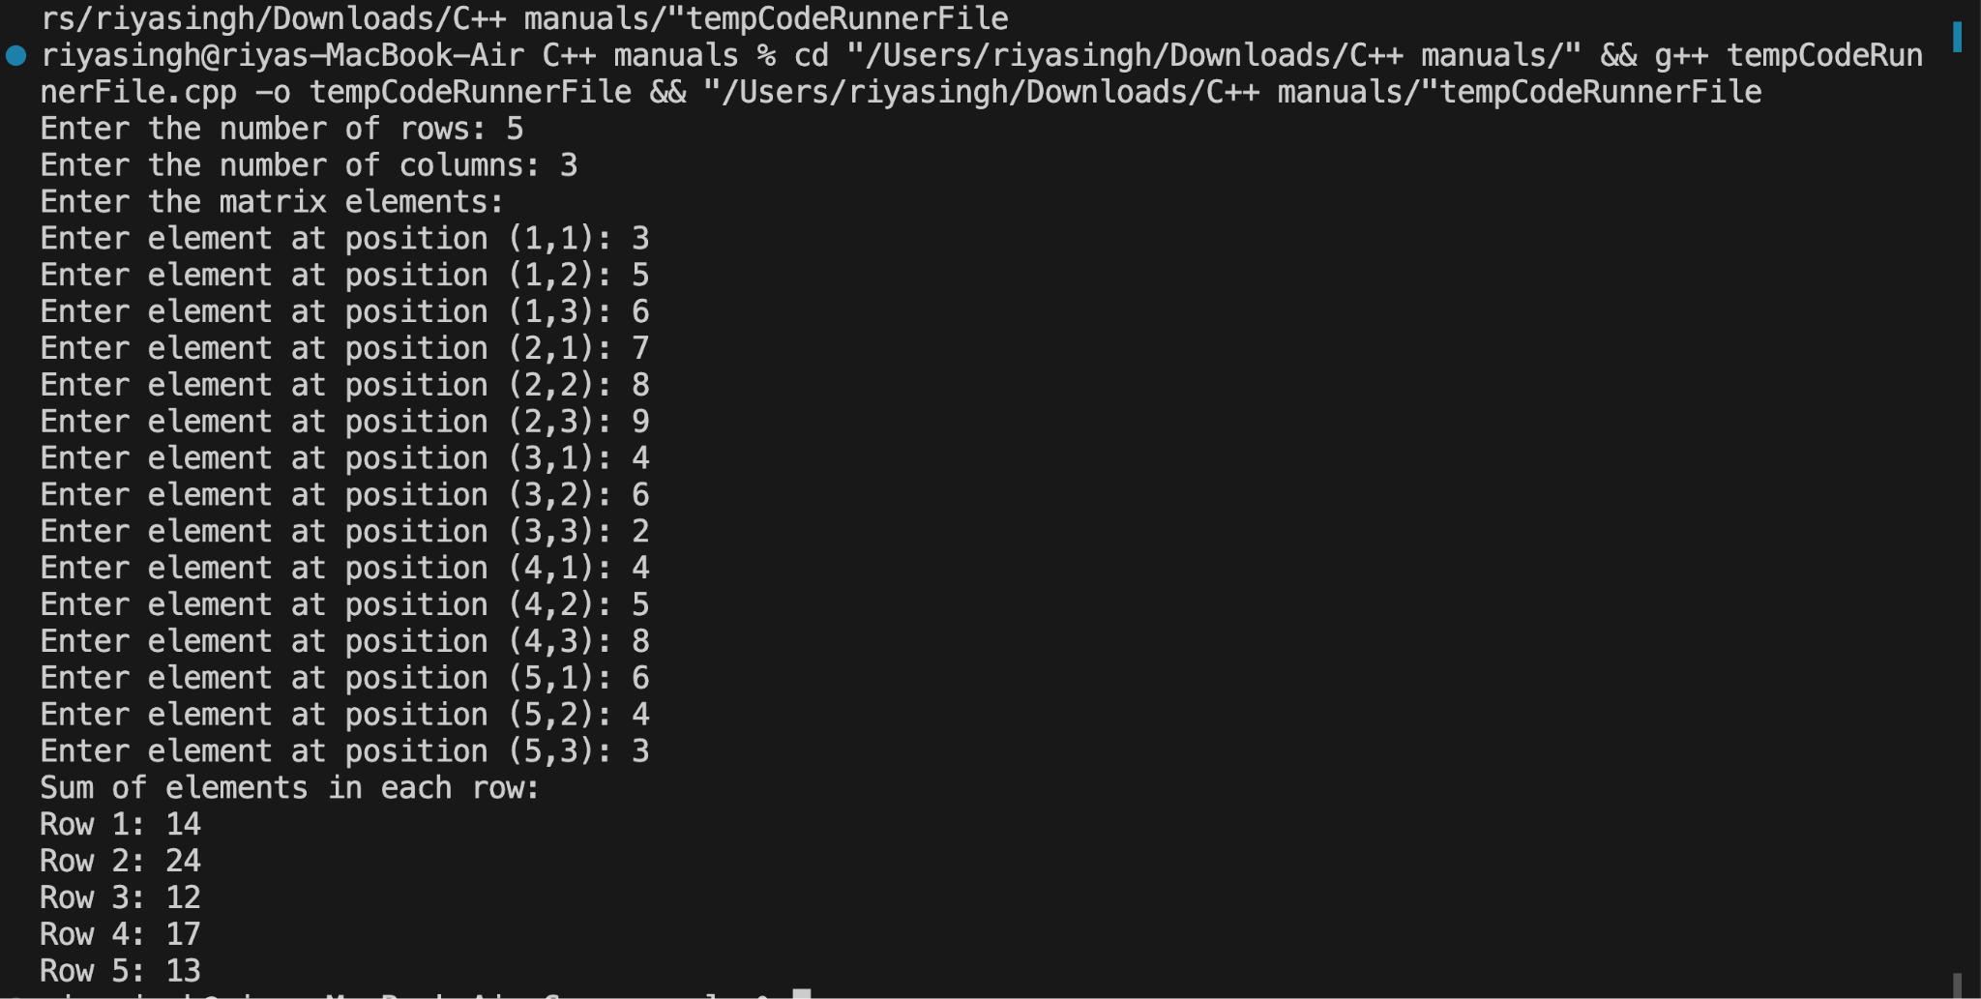

**2.**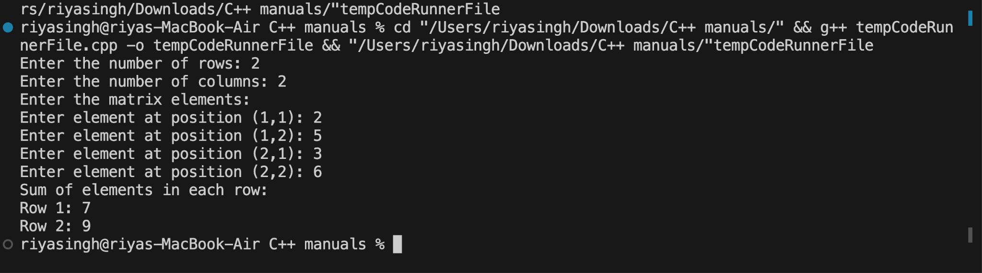

**CONCLUSION :** The program successfully calculates and displays the sum of elements in each row of a matrix, providing a clear and organized output.

**Experiment No:13**

**TITLE** : Write a program to generate all possible permutations of a string.

**THEORY** :The program generates all possible permutations of a string using recursive backtracking. • It uses a function that allows to check for the next permutation.

**Code :**

**#include <iostream>**

**using namespace std;**

**int main() {**

**int a = 0;**

**string input_string;**

**cout<<"Enter a word : ";**

**cin>>input_string;**

**sort(input_string.begin(), input_string.end());**

**do {**

**cout << input_string << endl;**

**a++;**

**} while (next_permutation(input_string.begin(),**

**input_string.end()));**

**cout<<"\n\nTOTAL PERMUTATIONS : "<<a;**

**return 0;**

**}**

**Output (Screenshot):**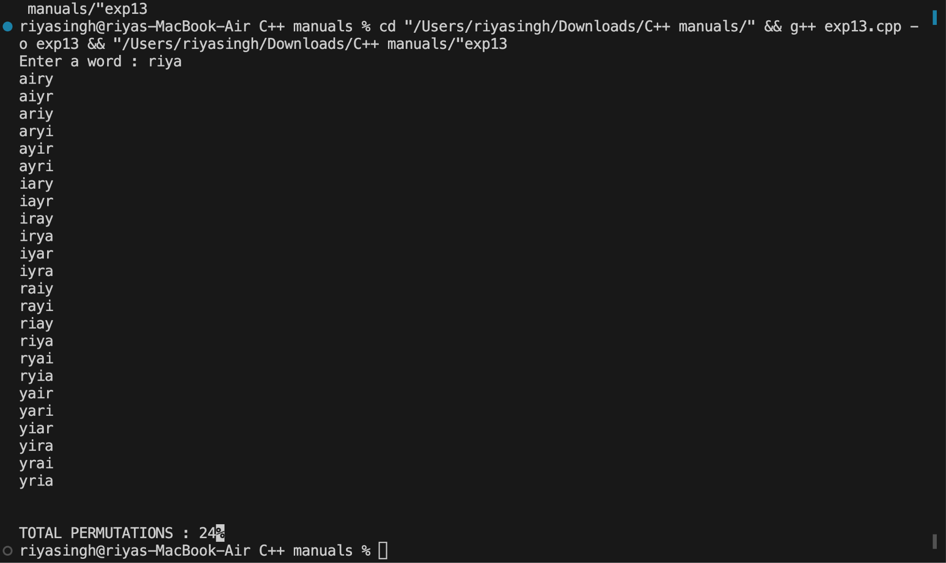

**Test Result (Any 2 Screenshot):1.**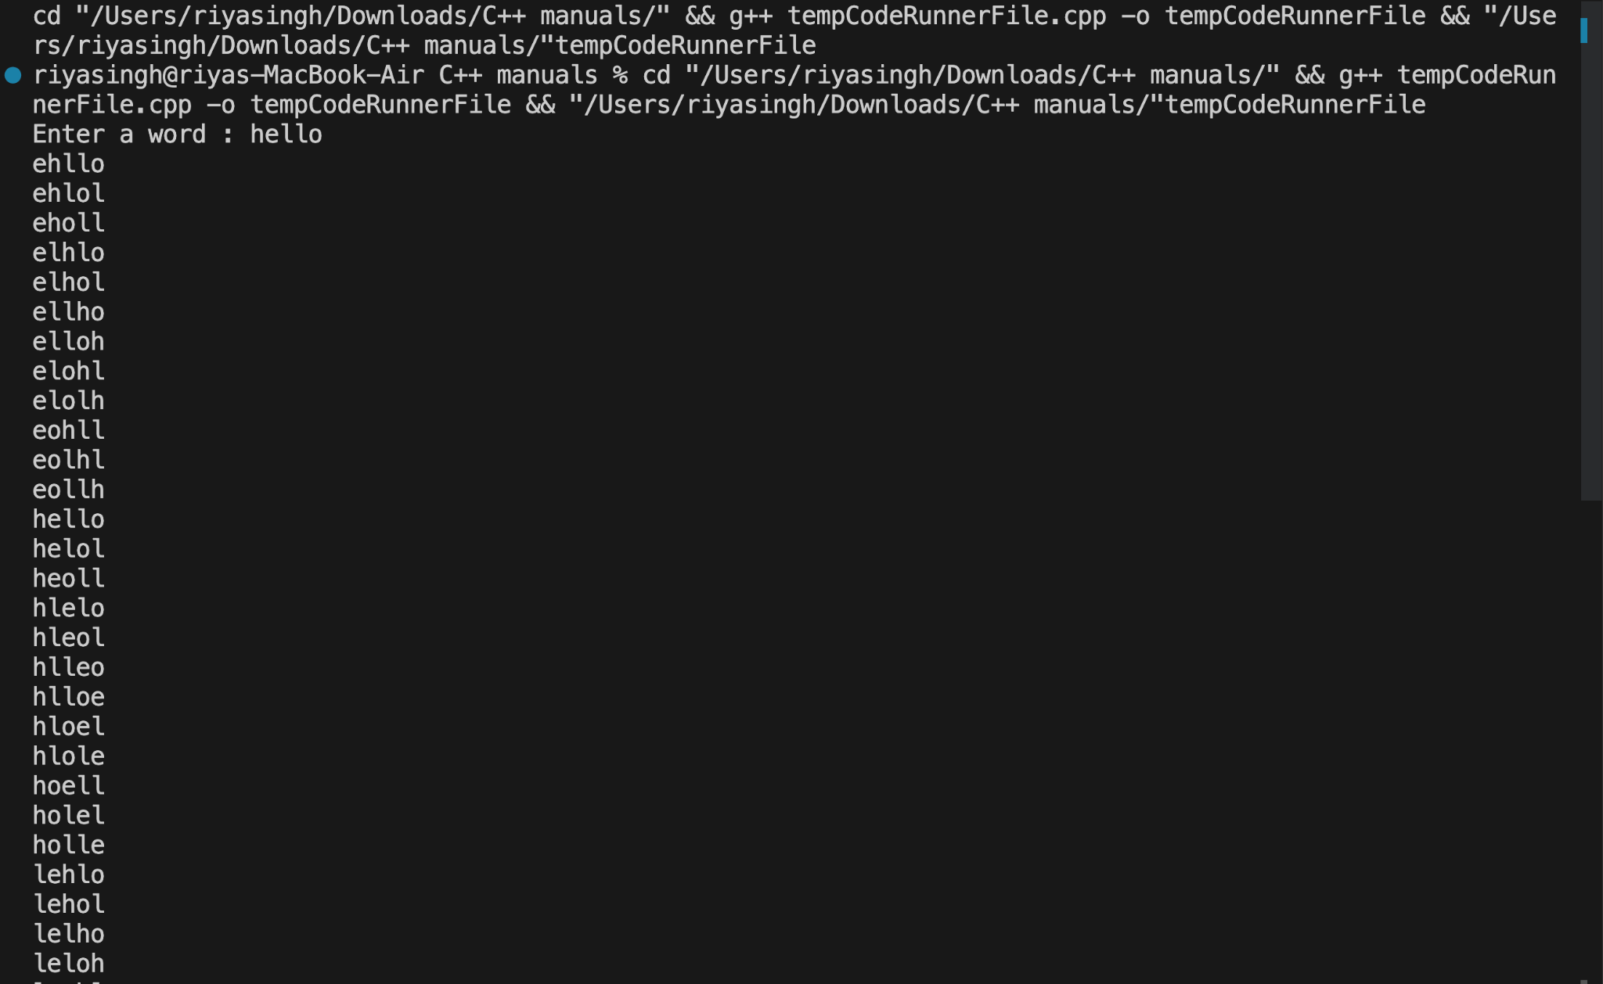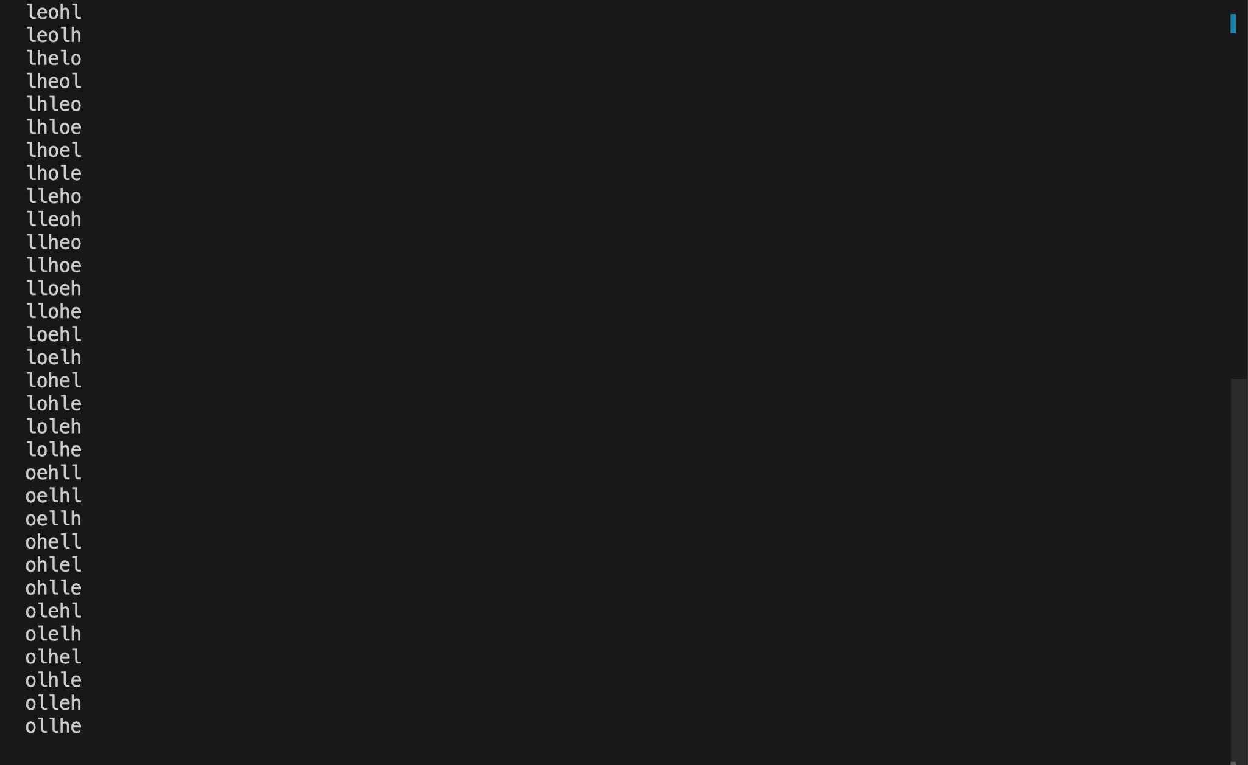

**2.**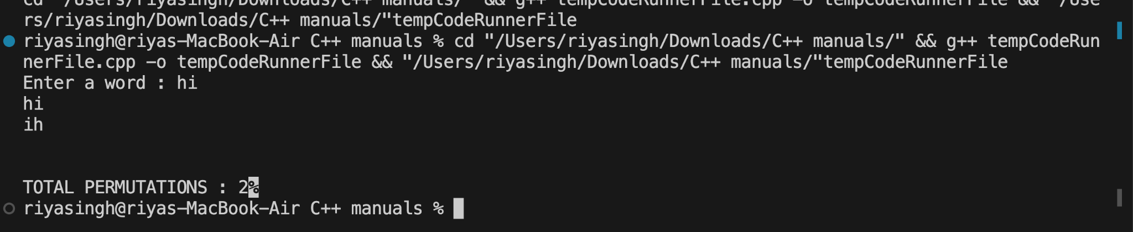

**CONCLUSION:** The program accurately generates all possible permutations of a string, systematically exploring and displaying each combination.

**Experiment No:14**

**TITLE**-Create a C++ program to print the following pattern:

*****

* *

* *

* *

*****

**THEORY :**The pattern consists of five rows and five columns. • '*' is printed in the first and last row, and first and last column, while spaces are printed in the interior

**Code :**

**#include<iostream>**

**using namespace std;**

**int main() {**

**int n ;**

**cout << "Enter a value of n : ";**

**cin >> n;**

**for(int i = 1; i <= n; i++) {**

**for(int j = 1; j <= n; j++) {**

**if(i == 1 || i == n|| j == 1 || j == (n-1)) {**

**cout << "*";**

**}**

**else {**

**cout << " ";**

**}**

**}**

**cout << endl;**

**}**

**return 0;**

**}**

**Output(Screenshot):**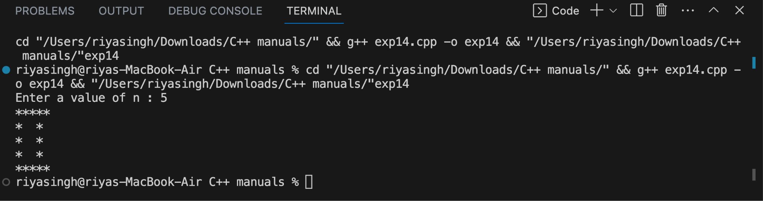

**Test Result(Any 2 Screenshot):1.**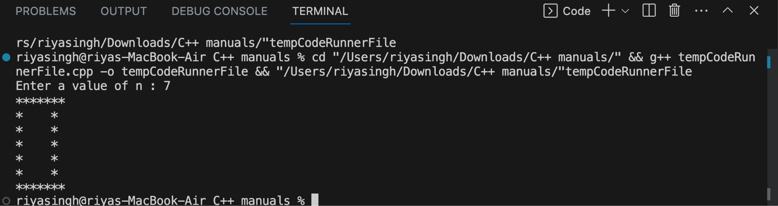

**2.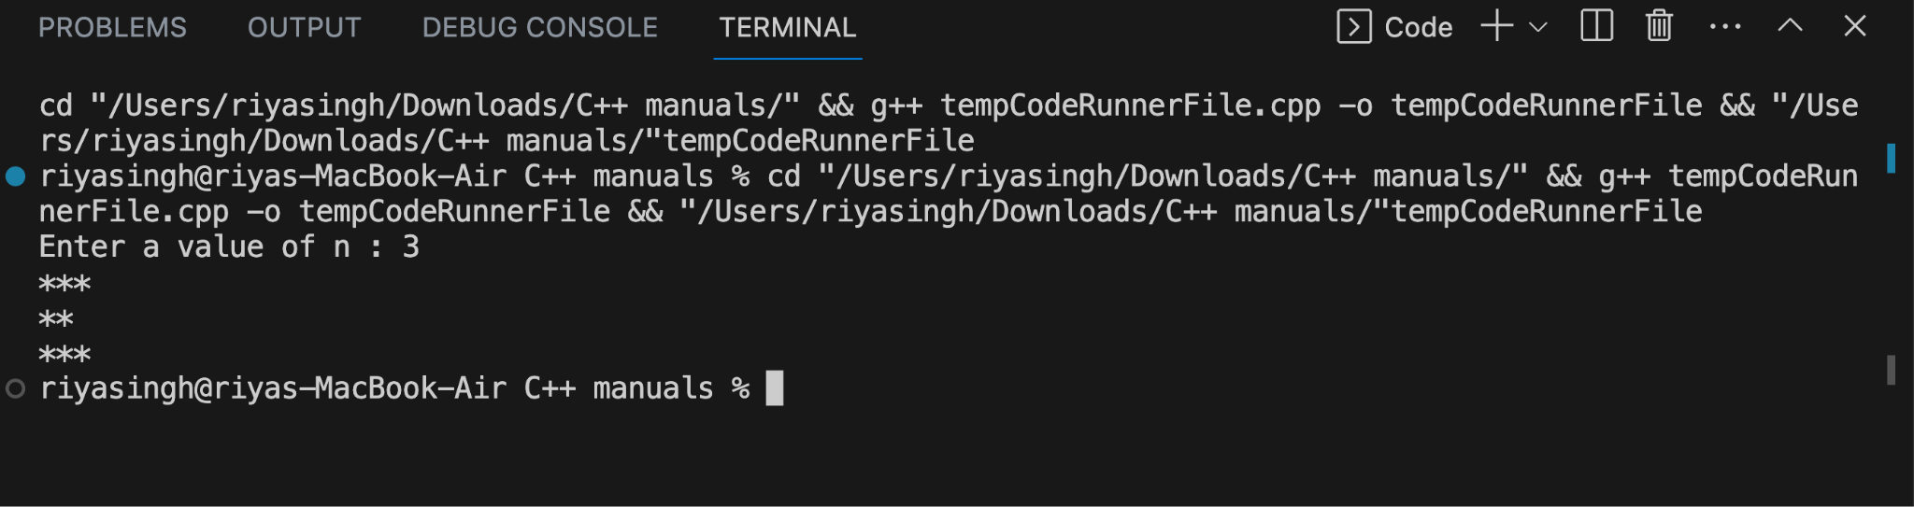CONCLUSION :** This C++ program successfully creates the desired pattern with a combination of '*' and spaces, following the specified row and column structure.

**Experiment No:15**

**TITLE-**Write a C++ program to display the following pattern:

1

232

34543

4567654

34543

232

**THEORY**- The pattern has a symmetric structure with numbers increasing in the first half and decreasing in the second half. Each row has numbers based on its position in the pattern.

**Code :**

**#include <iostream>**

**using namespace std;**

**int main()**

**{**

**int n, displayNum = 0, range = 0;**

**cout << "Enter the number of rows: ";**

**cin >> n;**

**for (int i = 1; i < 2 * n; i++)**

**{**

**range = i > n ? 2 * n - i : i;**

**displayNum = range;**

**for (int j = 0; j < 2 * range - 1; j++)**

**{**

**cout << displayNum;**

**displayNum = range > j + 1 ? displayNum + 1 : displayNum - 1;**

**}**

**cout << endl;**

**}**

**}**

**Output(Screenshot):**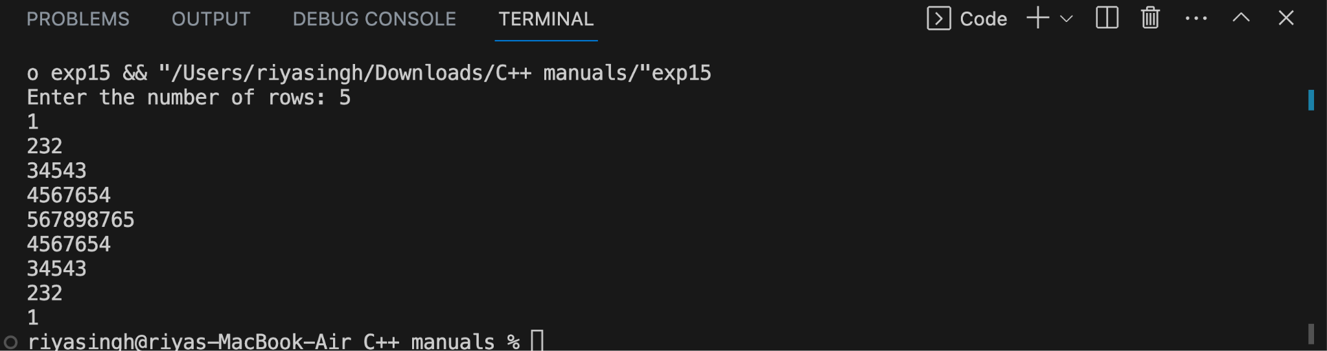

**Test result(Any 2 Screenshot):1.**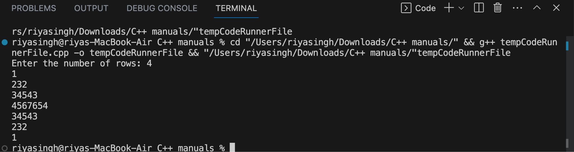

**2.**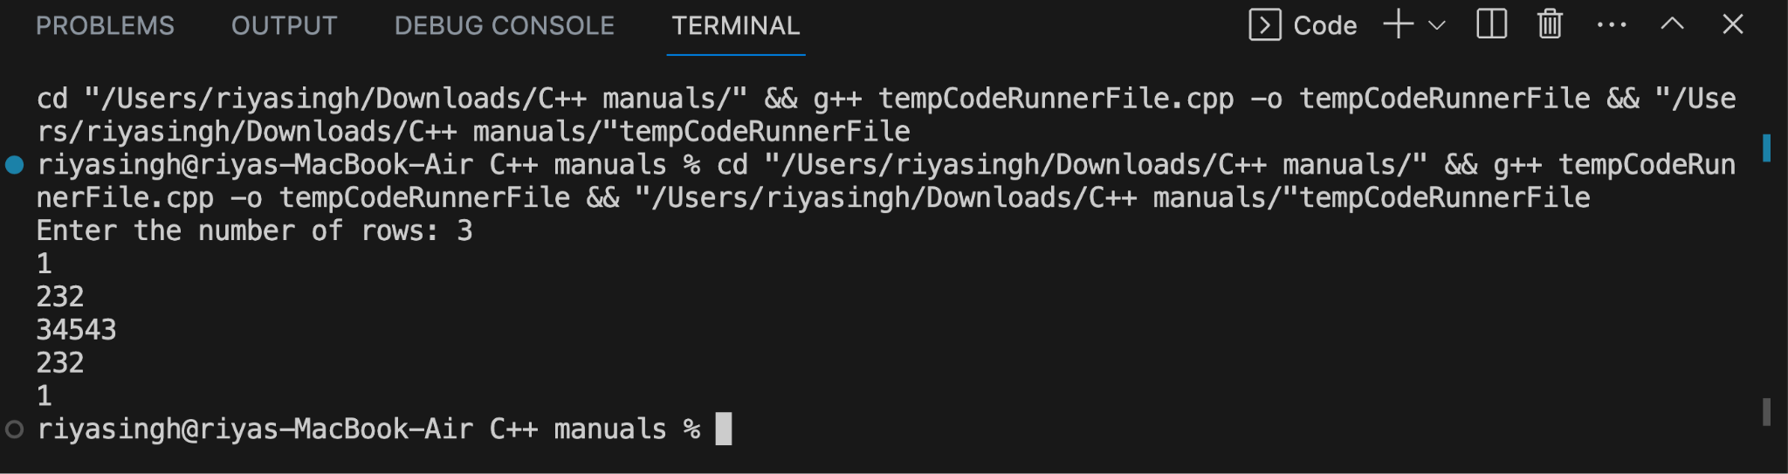

**CONCLUSION :**This C++ program generates the requested pattern, with numbers increasing and then decreasing in a symmetric manner

**ExperimentN0–16**

**TITLE :**Write a program to creating an inventory management system for a small store. The system should use object-oriented principles in C++. Your program should have the following features: • Create a Product class that represents a product in the inventory. Each Product object should have the following attributes: • Product ID (an integer) • Product Name (a string) • Price (a floating-point number) • Quantity in stock (an integer) • Implement a parameterized constructor for the Product class to initialize the attributes when a new product is added to the inventory.

**THEORY-**Object-oriented principles in C++ are employed to design an inventory management system. • The Product class encapsulates attributes such as Product ID, Product Name, Price, and Quantity in Stock, with a parameterized constructor facilitating the initialization of these attributes for each new product

**Code :**

**#include <iostream>**

**#include <string>**

**using namespace std;**

**class Product**

**{**

**private:**

**int productId;**

**string productName;**

**float price;**

**int quantityInStock;**

**public:**

**Product(int id, const string &name, float p, int quantity)**

**: productId(id), productName(name), price(p), quantityInStock(quantity) {}**

**void displayProductDetails()**

**{**

**cout << "Product ID: " << productId << endl;**

**cout << "Product Name: " << productName << endl;**

**cout << "Price: $" << price << endl;**

**cout << "Quantity in Stock: " << quantityInStock << endl;**

**cout << "------------------------" << endl;**

**}**

**void updateQuantity(int quantity)**

**{**

**quantityInStock += quantity;**

**}**

**};**

**int main()**

**{**

**Product product1(1, "Laptop", 999.99, 10);**

**Product product2(2, "Smartphone", 499.99, 20);**

**Product product3(3, "Headphones", 49.99, 30);**

**cout << "Initial Product Details:" << endl;**

**product1.displayProductDetails();**

**product2.displayProductDetails();**

**product3.displayProductDetails();**

**product1.updateQuantity(-5);**

**cout << "Product Details after Quantity Update:" << endl;**

**product1.displayProductDetails();**

**product2.displayProductDetails();**

**product3.displayProductDetails();**

**return 0;**

**}**

**Output(Screenshot):**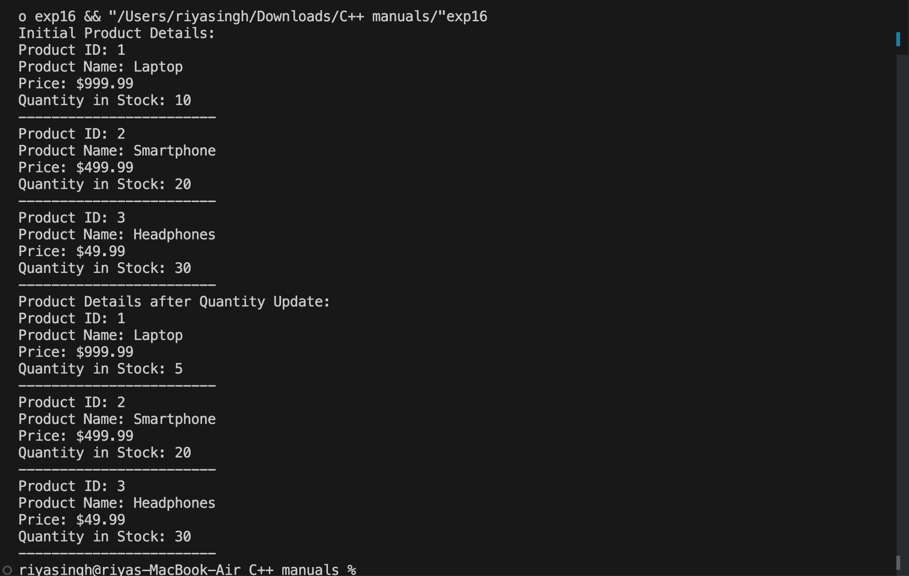

**Test Result (Any 2 screenshot):Same as above.**

**CONCLUSION:** The program establishes a foundation for a small store's inventory management. • Utilizing the Product class allows for the creation, storage, and retrieval of product details, adhering to object-oriented principles for modularity and reusability in an inventory management system.

**ExperimentN0–17**

**TITLE**-Write a program to manage student records. Create a class Student with attributes such as name, roll number, and marks. Implement methods for displaying student details, adding new students, and calculating the average marks of all students in the record system.

**THEORY** :The program utilizes object-oriented principles to manage student records in C++. • The Student class is designed with attributes such as name, roll number, and marks, and methods for displaying student details. Another class, StudentRecord, manages a collection of student objects, providing methods to add new students and calculate the average marks of all students in the record system.

**Code :**

**#include <iostream>**

**using namespace std;**

**class Student {**

**private:**

**string name;**

**int rollNumber;**

**float marks;**

**public:**

**Student(const string& studentName, int studentRollNumber, float studentMarks)**

**: name(studentName), rollNumber(studentRollNumber), marks(studentMarks) {}**

**void displayStudentDetails() const {**

**cout << "Name: " << name << endl;**

**cout << "Roll Number: " << rollNumber << endl;**

**cout << "Marks: " << marks << endl;**

**cout << "------------------------\n";**

**}**

**const string& getName() const { return name; }**

**void setName(const string& studentName) { name = studentName; }**

**int getRollNumber() const { return rollNumber; }**

**void setRollNumber(int studentRollNumber) { rollNumber = studentRollNumber; }**

**float getMarks() const { return marks; }**

**void setMarks(float studentMarks) { marks = studentMarks; }**

**};**

**class StudentRecordSystem {**

**private:**

**vector<Student> studentRecords;**

**public:**

**void addStudent() {**

**string name;**

**int rollNumber;**

**float marks;**

**cout << "Enter student details:\n";**

**cout << "Name: ";**

**cin.ignore();**

**getline(cin, name);**

**cout << "Roll Number: ";**

**cin >> rollNumber;**

**cout << "Marks: ";**

**cin >> marks;**

**studentRecords.push_back(Student(name, rollNumber, marks));**

**cout << "Student added successfully!\n";**

**}**

**void displayAllStudents() const {**

**if (studentRecords.empty()) {**

**cout << "No student records available.\n";**

**} else {**

**cout << "Student Details:\n";**

**for (const auto& student : studentRecords) {**

**student.displayStudentDetails();**

**}**

**}**

**}**

**void calculateAndDisplayAverageMarks() const {**

**if (studentRecords.empty()) {**

**cout << "No student records available.\n";**

**} else {**

**float totalMarks = 0;**

**for (const auto& student : studentRecords) {**

**totalMarks += student.getMarks();**

**}**

**float averageMarks = totalMarks / studentRecords.size();**

**cout << "Average Marks of All Students: " << averageMarks << std::endl;**

**}**

**}**

**};**

**int main() {**

**StudentRecordSystem recordSystem;**

**recordSystem.addStudent();**

**recordSystem.addStudent();**

**recordSystem.addStudent();**

**recordSystem.displayAllStudents();**

**recordSystem.calculateAndDisplayAverageMarks();**

**return 0;**

**}**

**Output(Screenshot):**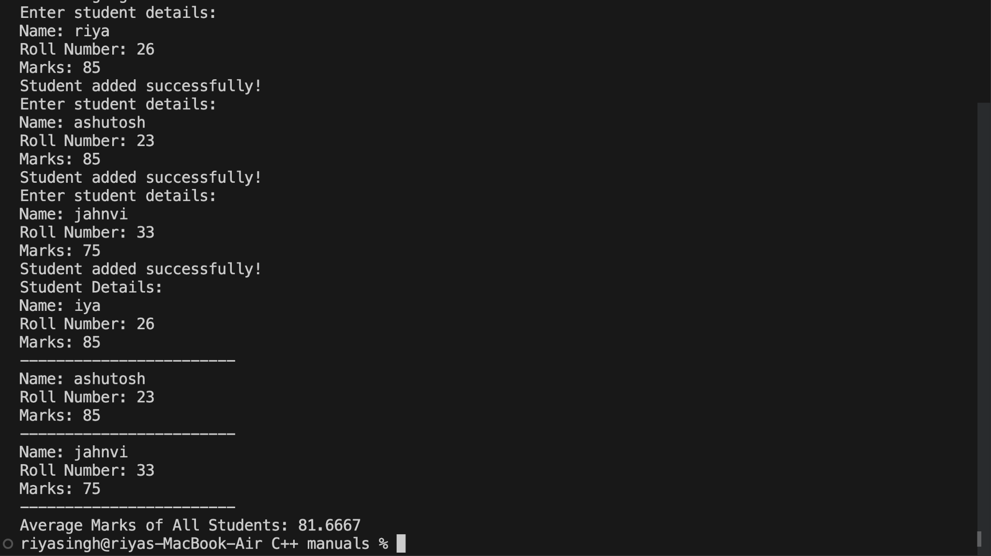

**Test Result(Any 2 Conclusion):1.**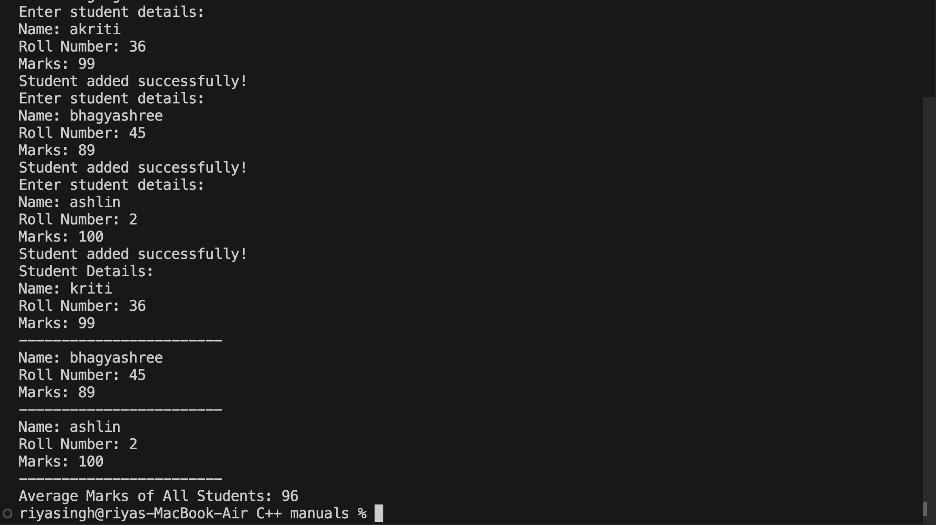

**2.**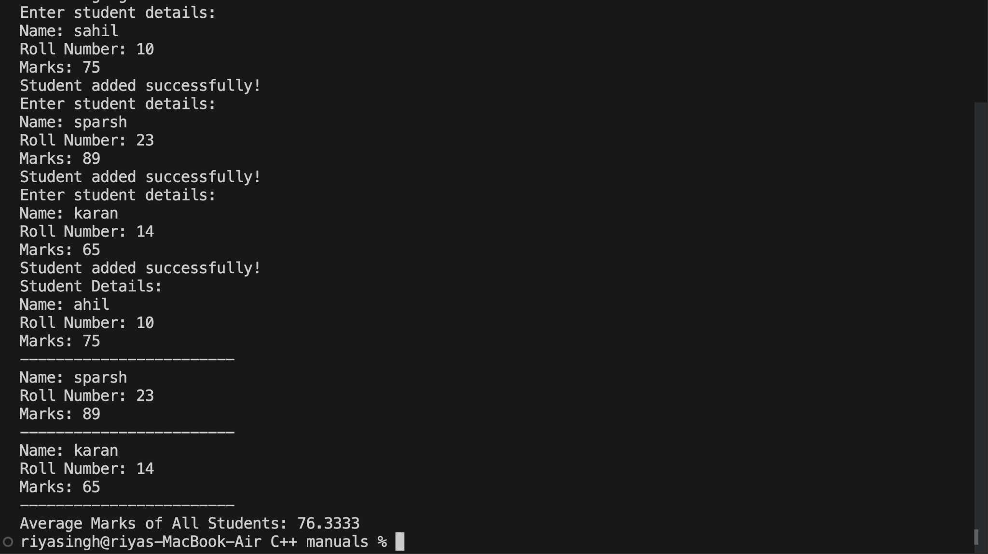

**Conclusion:**This basic student records management system provides a foundation for tracking and managing student information. Depending on your specific requirements, you can extend this program by adding more features such as updating student details, searching for a student by roll number, or storing data persistently in a database. This example serves as a starting point that can be customized and expanded based on the needs of the application.

**ExperimentN0–18**

**TITLE**-Write a program that implements a basic calculator. Use a class Calculator with methods to perform addition, subtraction, multiplication, and division of two numbers. The program should allow the user to input two numbers and select an operation to perform

**THEORY** * The program implements a basic calculator using the C++ programming language. • A class named Calculator is designed to perform four basic arithmetic operations: addition, subtraction, multiplication, and division.

**Code :**

**#include <iostream>**

**using namespace std;**

**class Calc**

**{**

**private:**

**int a, b;**

**char opr;**

**double sum;**

**public:**

**void getnum()**

**{**

**cout << "Enter first number : ";**

**cin >> a;**

**cout << "Enter Second number : ";**

**cin >> b;**

**rerun:**

**cout << "Enter the Operation you want to perform : (+,-,*,/,%) : ";**

**cin >> opr;**

**switch (opr)**

**{**

**case '+':**

**sum = addition(a, b);**

**cout << "ADDITION OF TWO NUM : " << a << " + " << b << " = " << sum;**

**break;**

**case '-':**

**sum = subtraction(a, b);**

**cout << "SUBTRACTION OF TWO NUM : " << a << " - " << b << " = " << sum;**

**break;**

**case '*':**

**sum = multiplication(a, b);**

**cout << "MULTIPLICATION OF TWO NUM : " << a << " x " << b << " = " << sum;**

**break;**

**case '/':**

**sum = division(a, b);**

**cout << "DIVISION OF TWO NUM : " << a << " / " << b << " = " << sum;**

**break;**

**case '%':**

**sum = modulus(a, b);**

**cout << "REMAINDER OF TWO NUM DIVISON : " << a << " & " << b << " = " <<**

**modulus(a, b);**

**break;**

**default:**

**cout << "WRONG INPUT \n\n";**

**goto rerun;**

**}**

**}**

**double addition(double a, double b)**

**{**

**return a + b;**

**}**

**double multiplication(double a, double b)**

**{**

**int c, d;**

**double mult;**

**c = a * 1000;**

**d = b * 1000;**

**mult = (c * d) / 1000000;**

**return mult;**

**}**

**double division(double a, double b)**

**{**

**int c, d;**

**double mult;**

**c = a;**

**d = b;**

**mult = int(c / d);**

**return mult;**

**}**

**double subtraction(double a, double b)**

**{**

**return a - b;**

**}**

**double modulus(double a, double b)**

**{**

**return int(a) % int(b);**

**}**

**void showhistory()**

**{**

**cout << a << " " << opr << " " << b << " = " << sum << endl;**

**}**

**};**

**int main()**

**{**

**int n = 100, i = 0;**

**Calc cal[n];**

**char x, y;**

**do**

**{**

**cal[i].getnum();**

**i++;**

**cout << "\nDo you want to do some more calc? (Y-yes, N-no)";**

**cin >> y;**

**if (toupper(y) == 'N')**

**{**

**break;**

**}**

**} while (i < n);**

**cout << "\n\nCalc HISTORY : \n";**

**for (int j = 0; j < i; j++)**

**{**

**cal[j].showhistory();**

**}**

**return 0;**

**}**

**Output(Screenshot):**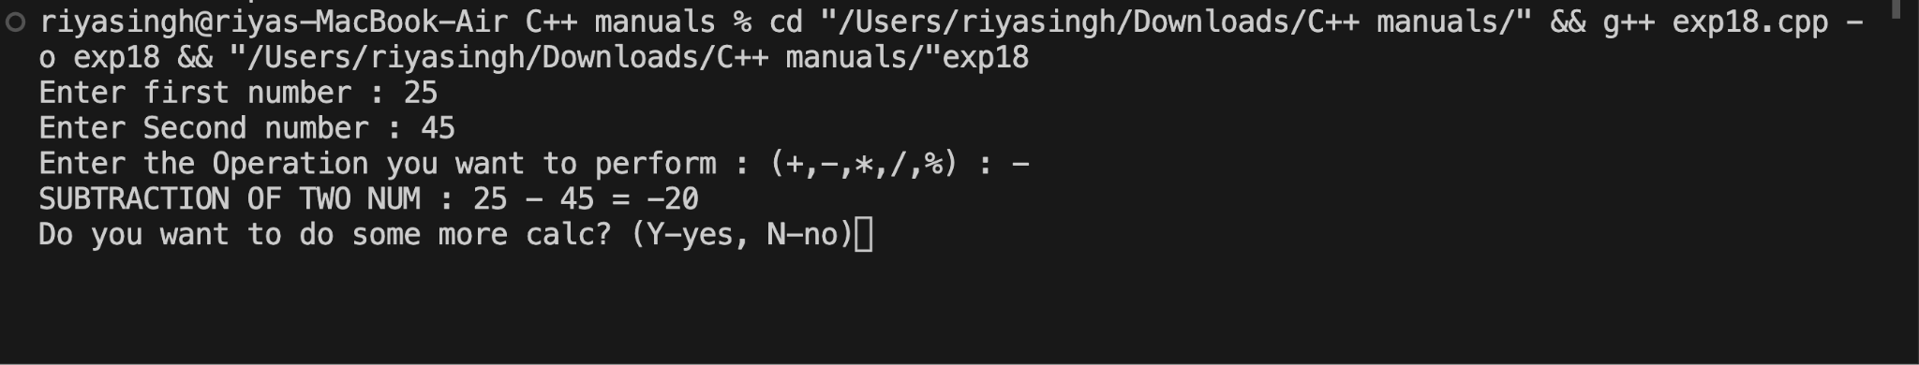

**Test Result(Any 2 Screenshot):1.**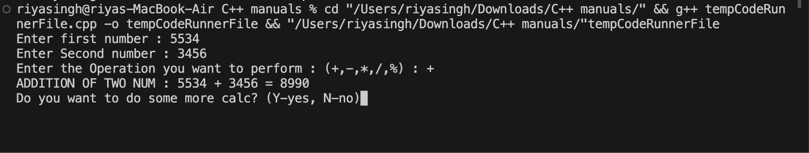

**2.**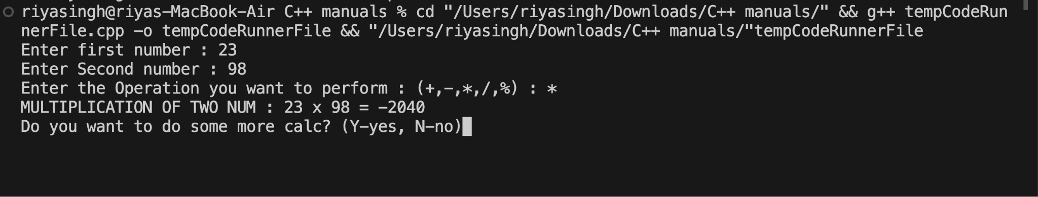

**CONCLUSION :**The Calculator class provides methods for each arithmetic operation, enhancing modularity. • The program allows the user to input two numbers and select an operation, ensuring basic calculator functionality with error handling for division by zero.

**ExperimentN0–19**

**TITLE-**Write a program to simulate a simple online shop. Create a class Product with attributes like name, price, and quantity in stock. Implement methods for adding products to the shopping cart, calculating the total cost, and displaying the contents of the cart.

**THEORY**- • The program models a simple online food ordering system using classes and vectors. • Utilizes object-oriented programming concepts, encapsulating items, menu, and orders. • Demonstrates a menu-driven interface, allowing users to add items to the cart . • Facilitates a seamless interaction for ordering food, enhancing user experience. • Emphasizes modularity, scalability, and code readability in C++ programming.

**Code** :

#include <iostream>

using namespace std;

const int MAX_PRODUCTS = 100;

const int MAX_CART_SIZE = 10;

class Product {

private:

string name;

double price;

int quantityInStock;

public:

// Constructor to initialize attributes

Product(string n, double prc, int qty)

: name(n), price(prc), quantityInStock(qty) {}

// Getter methods

string getName() const { return name; }

double getPrice() const { return price; }

int getQuantityInStock() { return quantityInStock; }

// Method to display product details

void displayDetails() const {

cout << "Product: " << name << "\tPrice: $" << price << "\tQuantity in Stock: " <<

quantityInStock << endl;

}

};

// ShoppingCart class representing the shopping cart

class ShoppingCart {

private:

Product* cart[MAX_CART_SIZE];

int cartSize;

public:

// Constructor

ShoppingCart() : cartSize(0) {}

// Method to add a product to the shopping cart

void addProduct(Product* product) {

if (cartSize < MAX_CART_SIZE && product->getQuantityInStock() > 0) {

cart[cartSize++] = product;

cout << product->getName() << " added to the cart.\n";

} else {

cout << "Cannot add more products to the cart.\n";

}

}

// Method to calculate the total cost of products in the cart

double calculateTotalCost() {

double totalCost = 0;

for (int i = 0; i < cartSize; ++i) {

totalCost += cart[i]->getPrice();

}

return totalCost;

}

// Method to display the contents of the cart

void displayCartContents() {

cout << "Shopping Cart Contents:\n";

for (int i = 0; i < cartSize; ++i) {

cart[i]->displayDetails();

}

cout << "--------------------------\n";

cout << "Total Cost: $" << calculateTotalCost() << endl;

}

};

int main() {

// Creating products

Product product1("Laptop", 899.99, 5);

Product product2("Smartphone", 499.99, 10);

Product product3("Headphones", 79.99, 20);

// Creating a shopping cart

ShoppingCart cart;

// Adding products to the shopping cart

cart.addProduct(&product1);

cart.addProduct(&product2);

cart.addProduct(&product3);

// Displaying the contents of the cart

cart.displayCartContents();

return 0;

}

**Output(Screenshot):**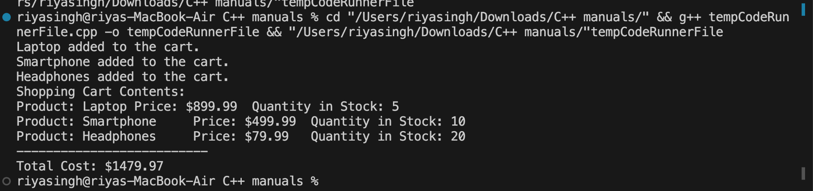

**Test Case :(Any 2 Screenshot):**Same as Above

**Conclusion**: Shopping cart simulation made using classes and functions, Emphasising on usage of pointers.

**ExperimentN0–20**

**TITLE**: Write a program to manage student grades for a classroom. Create a class Student with attributes for student name and an array to store grades. Implement methods for adding grades, calculating the average grade, and displaying the student's name and grades. Use constructors and destructors to initialize and release resources.

**THEORY**: • Student class manages grades with encapsulation. • Constructors initialize, and destructors release resources.

**Code :**

**#include <iostream>**

**#include <string>**

**using namespace std;**

**class Student {**

**private:**

**string studentName;**

**int* grades;**

**int numGrades;**

**public:**

**// Constructor to initialize attributes**

**Student(const string& name, int num)**

**: studentName(name), numGrades(num) {**

**// Allocate memory for grades array**

**grades = new int[numGrades];**

**// Initialize grades array**

**for (int i = 0; i < numGrades; ++i) {**

**grades[i] = 0;**

**}**

**}**

**// Destructor to release allocated memory**

**~Student() {**

**delete[] grades;**

**}**

**// Method to add grades**

**void addGrades(const int* newGrades) {**

**for (int i = 0; i < numGrades; ++i) {**

**grades[i] = newGrades[i];**

**}**

**}**

**// Method to calculate the average grade**

**double calculateAverageGrade() const {**

**if (numGrades == 0) {**

**return 0.0;**

**}**

**int total = 0;**

**for (int i = 0; i < numGrades; ++i) {**

**total += grades[i];**

**}**

**return total / numGrades;**

**}**

**// Method to display student information**

**void displayStudentInfo() const {**

**cout << "Student Name: " << studentName << endl;**

**cout << "Grades: ";**

**for (int i = 0; i < numGrades; ++i) {**

**cout << grades[i] << " ";**

**}**

**cout << "\nAverage Grade: " << calculateAverageGrade() << endl;**

**cout << "--------------------------\n";**

**}**

**};**

**int main() {**

**// Example usage**

**const int numGrades = 5;**

**int gradesArray[numGrades] = {85, 92, 78, 95, 88};**

**// Creating a student object**

**Student student("John Doe", numGrades);**

**// Adding grades to the student**

**student.addGrades(gradesArray);**

**// Displaying student information**

**student.displayStudentInfo();**

**return 0;**

**}**

**Output(Screenshot):**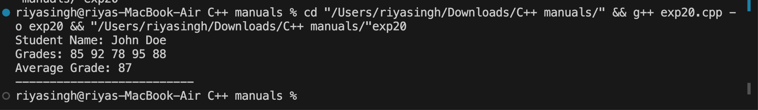

**Test Result(Any 2 Screenshot):same as above.**

**CONCLUSION :** Effective encapsulation ensures organized grade management. •Constructors and destructors enhance resource handling and code readability